Boston Medical Center
Baby Steps/ NICU Follow-Up Clinic
Department of Pediatrics
Yawkey Ambulatory Care Center
850 Harrison Avenue, 5th Floor
Boston, MA 02118
Appointments Call: 617.414.3668
bmc.org/programs/baby-steps

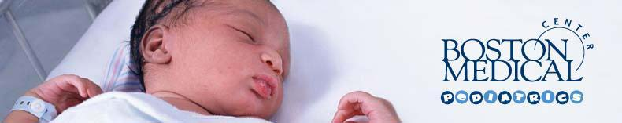

New In-Kind Donations are Welcomed Year Round
- Boppy pillows
- Level 1 Dr. Brown bottles and nipples
- Dr. Brown Slow Flow nipples
- Dr. Brown Preemie nipples
- Level 1 Avent bottles and nipples
- Avent Slow Flow nipples
- Avent Preemie nipples
- Breast Flow bottles and nipples
- Nipple shield (all sizes)
- Pumping bras
- Milk storage bags
- Swaddling blankets
- Play therapy or yoga mats
- Pack and plays
- Quiet noise music and sound machines
- Breast feeding education supplies (colorful in English and Spanish)
- Measuring spoons
- Baby feeding spoons
- Baby feeding bowls
- Soft top sippy cups
- Small rattles
- Newborn toys
- Measuring cups (including larger 1 or 2 Qt. cups)
Please call the Grow Clinic at (617) 414-5251 with any questions concerning donations.

