Accessing Clinical Applications via Mybmc.org
- Open Internet Explorer (Other browsers are not compatible i.e. Firefox, Chrome)
- Go to http://www.mybmc.org and select Clinical Applications.
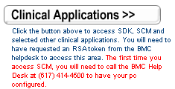
- Enter your logon credentials.
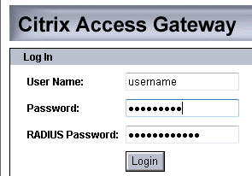
Username: Your regular BMC username.
Password: You BMC network password. (Same as your BMC email & Citrix password).
Radius Password: Last 4 numbers of your social security number + numbers on the token. Make sure you enter the numbers in all together as one password.

- You will then see a “Starting Session” screen appear with an Active X control popup.
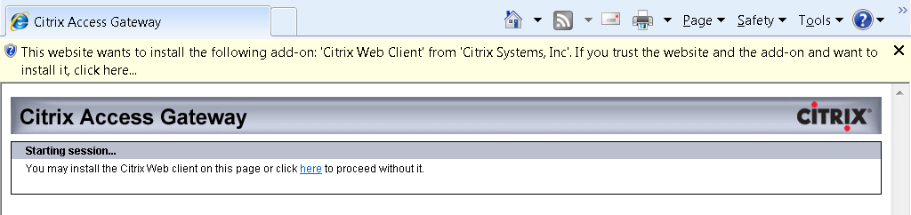
- Go ahead and right click on: The website wants to install the following add-on: Citrix Web Client….
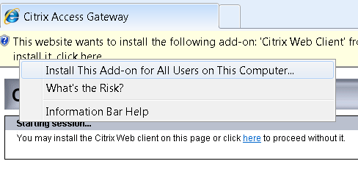
- Then select “Install this Add-on for all users on this computer.”
- Choose Yes when prompted by windows to allow changes to be made to the computer by Citrix.
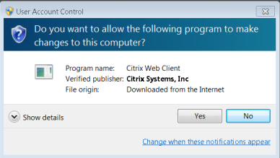

- Select the correct language. (English is default). Then click OK.
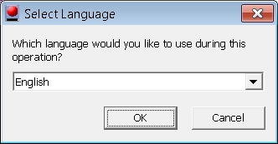

- Then select Yes when the Citrix License Agreement pops up.
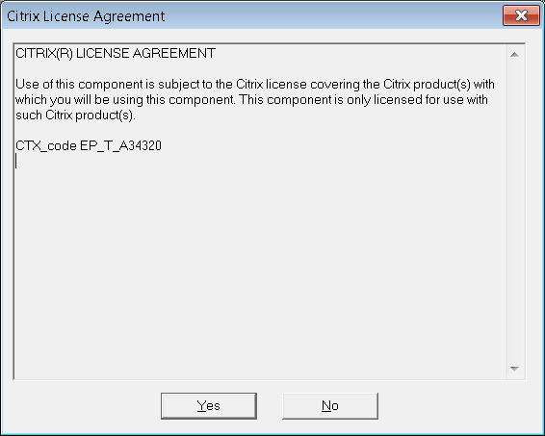

- You should now be connected to Citrix and able to access your citrix applications.
