Cost Center Changes and Allocations in Workday

- Are you changing an employee’s cost center 100%? Is the effective date in the future?
  - Use Change Organization Assignments
- Are you changing an employee’s cost center 100%? Is the effective date in the past?
  - Use Change Organization Assignments
  - Then use Costing Allocation
    - Start Date will be the effective date of the change
    - End Date will be the Saturday of the last pay period
- Are you splitting an employee’s cost center into multiple AUs?
  - Use Costing Allocation
Contents
Change Organization Assignments 1
Adding or Changing Costing Allocations 2

Change Organization Assignments
- Search for an employee and click on the employee’s profile.
- Click the Actions button Organization Change Organization Assignments
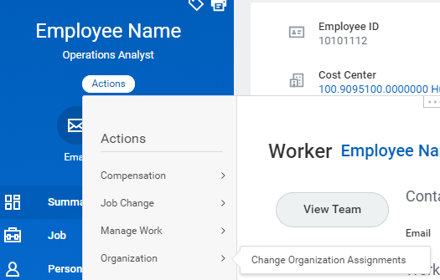
- Enter the effective date of the change, then click OK.
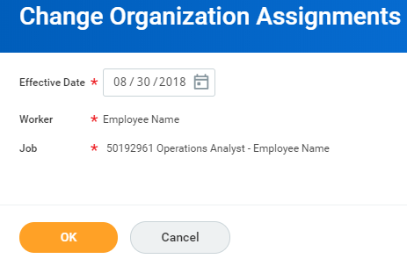
- In the last box, click into Cost Center and type in the new cost center, then hit enter. Then submit.
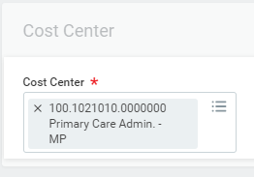

Adding or Changing Costing Allocations
- Search for an employee and click on the employee’s profile. Click on the Pay tab.
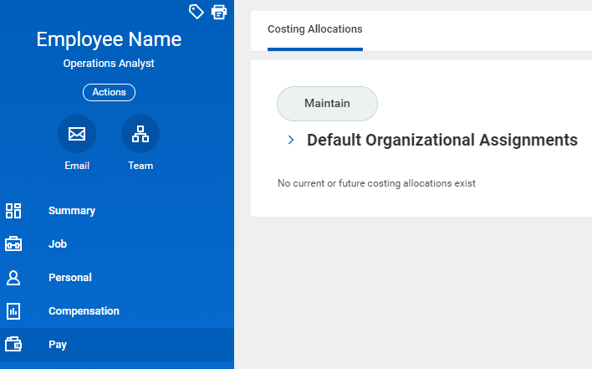
- If the employee has current allocations, a list of the employee’s current cost allocations will appear.
- Click on Maintain to make edits to the cost allocations. Do not make any changes on this next screen. Click OK.
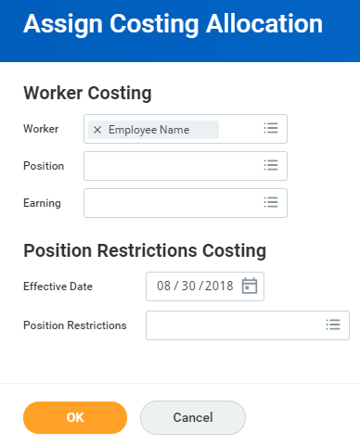

- If adding an allocation for the first time, fill out the form in its entirety. Then click Submit.
  - Allocation Start Date: Enter the date the cost allocation should be effective.
Please note: If the effective date is in a prior fiscal year, please first contact FIS.
- Allocation End Date: Enter the allocation end date. If you are unaware of the allocation end date, enter 12/31/9999.
Please note: The end date of a cost allocation should not overlap with the beginning of another allocation.
  - Costing Override: Select the cost center to distribute costs
  - Distribution Percent: Enter in the percentage of cost
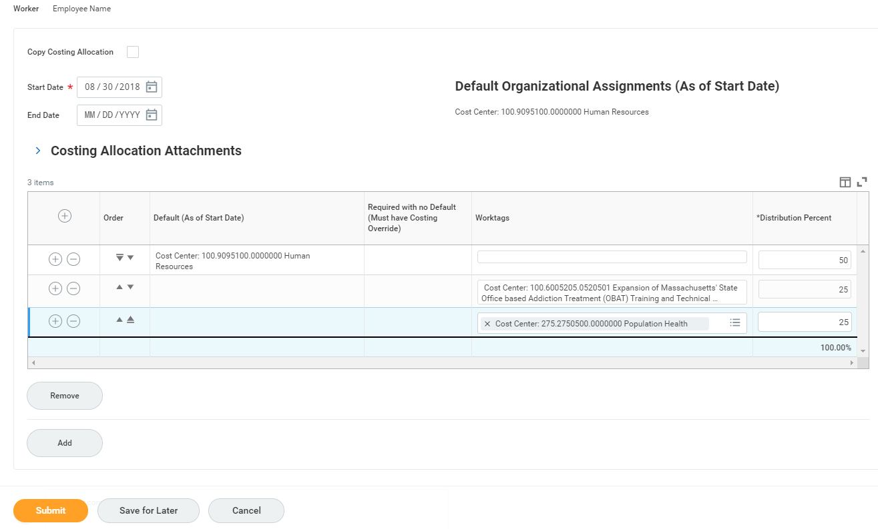
- If updating existing allocations, you will have to end current allocations and start the new one. You must do this even if you are merely changing distribution percent or if you are just changing one cost center to another.
- Current Allocation End Date: Enter the intended end date of the current allocation. Often it is the end of a pay period.
  - Click the Add button to add a new allocation or check Copy Costing Allocation box to pull in the details of the current allocation
- NEW Allocation Start Date: Enter the intended start date of the new allocation. Often it is the beginning of a pay period.
- NEW Allocation End Date: If the allocation has an end date, enter the date accordingly. If you are unaware of the allocation end date, enter 12/31/9999.
- New Costing Override: Select the cost center to distribute costs
- New Distribution Percent: Enter in the percentage of cost

Once you submit your allocation you will be able to see it reflected on the employee’s record, as well as see that it was completed in the employee’s Worker history. If the allocation was retroactive prior to the beginning of the current pay period (Effective date prior to the first day of the current week), it will route to someone in Accounting/Finance to complete any necessary payroll accounting adjustments. You will be able to track that progress in Worker History as well. Once that process is completed you will receive a notification in your Workday Notifications.

