

**WE CARE Family Resource Book Guide**

Table of Contents

|  |  |
| --- | --- |
| How to use this Guide | ………………………… 2 |
| Gathering Resources  Materials Needed for Physical FRB | ………………………… 4  ………………………… 5 |
| Family Resource Book Template | ………………………… 6 |
| Family Resource Book Cover Page | ………………………… 8 |
| Childcare Resources Cover Page | ………………………… 9 |
| *Childcare Resources Sample Handout* | ………………………. 10 |
| Employment Resources Cover Page | ………………………. 11 |
| *Employment Resources Sample Handout* | ………………………. 12 |
| Housing Resources Cover Page | ………………………. 13 |
| *Housing Resources Sample Handout* | ………………………. 14 |
| Food Resources Cover Page | ………………………. 15 |
| *Food Resources Sample Handout* | ………………………. 16 |
| Education Resources Cover Page | ………………………. 17 |
| *Education Resources Sample Handout* | ………………………. 18 |
| Utilities Resources Cover Page | ………………………. 19 |
| *Utilities Resources Sample Handout* | ………………………. 20 |
| Spine Label Templates | ………………………. 21 |

# How to use this Guide

Families who report *having a need* *and wanting help* on the WE CARE screener should be provided with WE CARE Family Resource Book (FRB) handout(s) corresponding to the need(s) with which they want help. These 1-page resource information handouts list community resources (e.g., food pantries) for each specific need (e.g., food insecurity) asked on the WE CARE screener.

The templates and sample handouts in this guide should be used to build your practice’s FRB resource information handouts. It is important that your FRB handouts be adapted to fit the resources available in your practice’s community, as resources vary widely depending on neighborhood, city, and state. The Family Resource Book should be **updated monthly** to ensure that all resources provided to families are up-to-date and accurate.

You can choose to have a physical Family Resource Book that contains the resource information handouts or upload the information sheets into your practice’s electronic record system. We recommend selecting the method(s) that are most helpful to your patients and providers.

The table below provides a brief comparison of the two methods:

|  |  |
| --- | --- |
| **Paper** | **Electronic** |
| Consists of a binder with separate tabs for each unmet social need assessed on the WE CARE screener. Each tab has multiple copies of need-specific handouts with resources. | Consists of EHR smart phrases used to print WE CARE resource handouts and add them to patients’ visit summaries (e.g., the smart phrase “.*WCHousingEng”* could populate an English housing resource handout in a patient’s visit summary). |
| The resource handouts can be distributed without reliance on the EHR if the EHR is not available or not working. | Resource sheets can be printed directly from the EHR (less paper waste and no upkeep required). |
| Binder copies must be reprinted/stocked by the individual designated with this responsibility. | There is a potential cost for embedding the resource handouts into the EHR. |
| The resource handouts can be provided by any staff member. | The resource handouts can only be provided by staff/providers with access to the EHR. |
| No automatic tracking of whether resource sheets have been given to family or not yet. | Distribution of the resource handouts may be automatically tracked in patient’s EHR (e.g., “food” handout printed in Feb 2019). |

**This guide includes:**

1. A list of materials you may need if you prefer a physical format of the FRB.
2. A template containing helpful links for identifying resources.
3. Sample cover pages for the six needs in the WE CARE screener.
   1. For physical formats of the FRB, these can be inserted as dividers between each section of resource handouts.
4. Need-specific FRB sample handouts for either physical or electronic formats of the FRB.
5. Example spine labels for the physical format of the FRB.

The FRB sample handouts are a guide for formatting your own physical or electronic FRB system. Insert information into the sample handouts pertaining to 3-4 of your own community’s resources. Include the following, when applicable:

* Name of the resource
* A brief description of the services provided by the resource
* Location (e.g., physical address, website URL, etc.)
* Hours of operation
* Contact information (e.g., telephone number, email, mailing address)
* Eligibility (e.g., requires family income level)
* Payment source (cost of services)
* Any other pertinent information

It is important to ensure that the information listed for each resource is clear and written at a reading level suitable for your practice’s families. You will have 2-4 months to identify resources in your community and develop your FRB handouts (and build your physical FRB, if applicable). This timeframe also includes final review of your FRB handouts and translation of them into Spanish by the WE CARE Study Team.

Of course, resource availability and contact information can change over time. The Family Resource Book should be **updated at least every month** to ensure that all resources provided to families are up-to-date and accurate.  You may need to update them more frequently if a family mentions they’ve had trouble reaching a resource, or if you become aware that information is out of date or that new resources are available. To facilitate the update process, keep an electronic version of your template. If the URL for a resource’s site is no longer active, try finding an alternative. If the webpage has been removed because the resource is no longer active, that resource should be removed from the information sheet. Same goes for contact information! Please check to make sure the phone numbers, addresses, and email addresses reflect the resources’ latest contact information. We do not want these handouts to present a dead-end for parents, so it’s important that they’re able to connect to the resources they try to contact.

We’ve noticed that COVID-19 has caused information about these resources to fluctuate more frequently. For example, hours of operation may change more often, some services and transportation options may no longer be available, and contact information may change as these resources close their offices and shift to virtual procedures. To directly reach the communities they help, some resources may post about these changes on their Facebook, Twitter, or Instagram accounts more often than their official websites. Some resources may also have a local website with more relevant updates, and then a larger organizational website if their resource has multiple locations. To stay as up-to-date as possible on what each resource still provides, we recommend checking their social media accounts as well as the multiple websites affiliated with their organization. This way, the information provided to families is as accurate as possible.

# Gathering Resources

In order to create your Family Resource Book, we recommend you visit the AAP’s Child Poverty Website: <https://www.aap.org/en-us/advocacy-and-policy/aap-health-initiatives/poverty/Pages/practice-tips.aspx>. Navigate to the section titled “Connecting Families to Community Resources,” and follow hyperlinks in the template to review national and statewide organizations that provide information on local resources. You can also use the template on page 6 of this guide to help you get started. We recommend working with community partners and other service providers to identify local services and resources. Helpful partners may include:

* Community resource aggregators like Aunt Bertha – The Social Care Network (<https://www.auntbertha.com/>)
* Local public health departments
* Hospitals, social workers
* Legal aid organizations
* Community action agencies
* Non-profit and faith-based organizations (e.g., Salvation Army)
* Call 2-1-1 help line (availability varies by state)
* Benefits.gov
* Community Needs Assessments (CNAs)

Also, the ongoing COVID-19 pandemic has no doubt affected the resources available in your area. Higher demand, fewer staff, and office closures mean that some of these resources may either not be able to provide as much assistance as before or not be open at all. Please be sure to find resources that provide as much assistance to families as possible during this time. We recommend resources with multiple services, locations, and a strong online presence, as they have a greater chance of staying open and able to help your families.

## *What do I say to resource staff members when they ask why I’m calling?*

When calling local community resources to confirm their contact information, sometimes staff working there may ask questions about who you are, what you need, and where you are located. You are under no obligation to disclose that your practice is participating in a research study. Instead, we recommend that you briefly describe the program you’re implementing at your practice and explain that you are calling to confirm their contact information so you can provide accurate information to your patients’ families. Below is a script the study team has developed to help you with these calls:

**“Hello! My name is __________________ (name), and I am a __________________ (role) at a local pediatric practice. We are implementing a new program that screens families for unmet needs and refers them to resources like yours to help them meet these needs. My understanding is that __________________ (name of organization you are calling) can help families __________________ (e.g., obtain healthy food, apply for public housing, enroll in a GED program, etc.). Is this accurate?**

**“Great! I’d like to confirm the contact information I gathered from __________________ (e.g., your website, a colleague who’s used your services before, etc.) is accurate. Could families in need still reach you at __________________ (phone, email, website, physical address, etc.)?**

**“Perfect! And finally, could you please contact me in the future if the information I just confirmed changes at all? I’ll be updating it every month but if anything changes before then, you can reach me at __________________ (preferred email or phone number). Thank you for your help today and for everything you do to support our community!”**

# Materials Needed for Physical FRB

*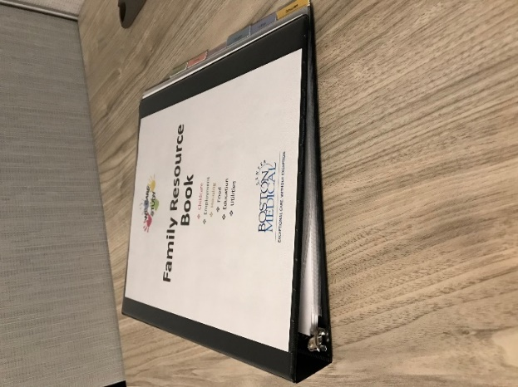The below list includes materials you may need to assemble your Family Resource Book if you choose the physical FRB (as opposed to EHR-integrated FRB handouts). The study team will provide your practice with these materials if you choose the physical FRB format:*

* **1 three-ring binder per exam room**
* **1 set of dividers per binder**
  + We suggest clear dividers with an insert pocket, such as: **Avery Protect 'n Tab Polypropylene/PP 8 Sheet Protectors, Clear, Set (74161)**
  + Place each resource cover page into a plastic divider and label tabs with resource domains as shown below:

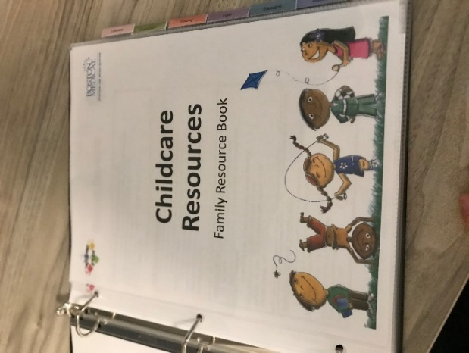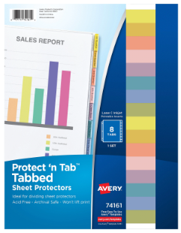

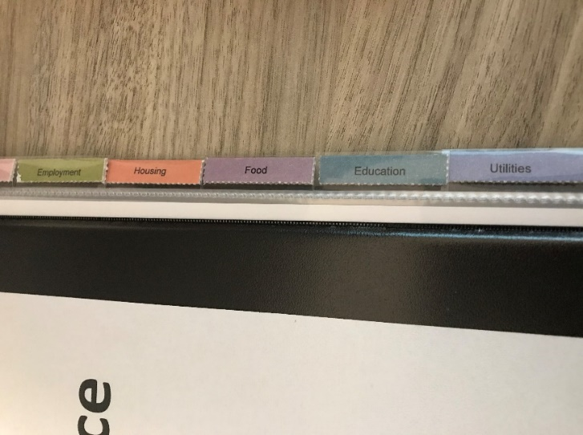

* **Three-hole punch**
  + 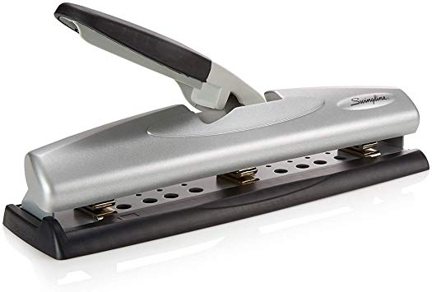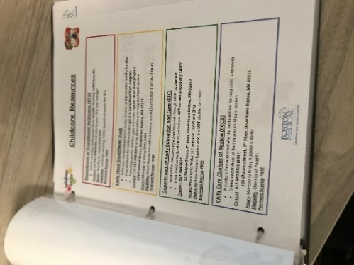The printed resource sheets for each domain should be three-hole punched and placed between the plastic dividers

# Family Resource Book Template

|  |
| --- |
| **Childcare and Education** |
| **WE CARE Question**   * **Do you need childcare for your child? If YES, would you like help finding it? => YES** |
| **Your Local Resources**  *(add your local resources and helpful notes/comments)* |
| [Early Head Start and Head Start Program Locator](http://www.benefits.gov/benefits/benefit-details/616) |
| [National Center for Homeless Education Helpline](http://center.serve.org/nche/helpline.php)  Assistance for homeless families with issues including school enrollment, transportation and other school-related issues. |
| [YMCA](http://www.ymca.net/) (out of school education programs may be available) |
| [Healthy Child Care America](http://www.healthychildcare.org/) |
| [Family Voices](http://www.familyvoices.org/action/join?id=0002) (special health care needs/disabilities) |
| [National Center for Learning Disabilities](http://ldnavigator.ncld.org/)  (Includes parent advocacy and support resources) |
| [Federal Student Aid](https://studentaid.ed.gov/sa/) (College Planning) |

|  |
| --- |
| **Jobs and Employment** |
| **WE CARE Question**   * **Do you have a full-time job? If NO, Do you want help finding one? => YES** |
| **Your Local Resources**  *(add your local resources and helpful notes/comments)* |
| [United Way 211](http://www.call211.org/)  Free national telephone service that helps identify health and human services. |
| [Community Action Agencies Across America](http://www.communityactionpartnership.com/index.php?option=com_spreadsheets&view=search&spreadsheet=cap&Itemid=188) (State by state network of Community Agencies that serve low-income and poor. Services may include help with emergency assistance, food and nutrition, Adult Basic education and employment, housing, money management, and transportation. |
| US Department of Labor  [State Unemployment Insurance Benefits](http://workforcesecurity.doleta.gov/unemploy/uifactsheet.asp) |

|  |
| --- |
| **Housing** |
| **WE CARE Question**   * **Do you think you are at risk of becoming homeless? If YES, would you like help with this? => YES** |
| **Your local resources**  *(add your local resources and helpful notes/comments)* |
| [US Department of Housing and Urban Development Resource Locator](http://resources.hud.gov/#&ui-state=dialog)  Includes information to apply for public housing, affordable housing and identify state homeless resources. |
| [National Coalition for the Homeless](http://nationalhomeless.org/references/directory/)  Directory of state homeless advocacy and service organizations |
| [The Low Income Home Energy Assistance Program Application](http://www.benefits.gov/benefits/benefit-details/623)  Federal energy assistance program assists low-income households with heating/energy assistance. |
| Local utility companies often offer programs for low income families for discounts or assistance |

|  |
| --- |
| **Food Security** |
| **WE CARE Question**   * **Do you always have enough food for your family? If NO, would you like help with this? => YES** |
| **Your Local Resources**  *(add your local resources and helpful notes/comments)* |
| [State WIC contacts](http://www.fns.usda.gov/wic/wic-contacts) |
| [SNAP application and local office locator](http://www.fns.usda.gov/snap/snap-application-and-local-office-locators) |
| [National School Lunch Program Application](http://www.fns.usda.gov/school-meals/applying-free-and-reduced-price-school-meals) |
| [Free Summer Meals Site Locator](http://www.fns.usda.gov/summerfoodrocks) |
| [Healthy Foodbank Hub/Foodbank Locator](https://healthyfoodbankhub.feedingamerica.org/) |
| [Child and Adult Care Food Program](http://www.cacfp.org/) |

|  |
| --- |
| **Parental Education** |
| **WE CARE Question**   * **Do you have a high school degree? If NO, would you like help to get a GED? => YES** |
| **Your Local Resources**  *(add your local resources and helpful notes/comments)* |
| [Reach Out and Read Program Finder](http://www.reachoutandread.org/resource-center/find-a-program/) |
| [YMCA](http://www.ymca.net/) (literacy programs may be available for children and adults) |
| [Community Action Agencies Across America](http://www.communityactionpartnership.com/index.php?option=com_spreadsheets&view=search&spreadsheet=cap&Itemid=188) (state by state agencies may provide support with Adult Basic Education, job training and employment) |

|  |
| --- |
| **Utilities** |
| **WE CARE Question**   * **Do you have trouble paying your heating/cooling, water or electricity bill? If YES, would you like help with this => YES** |
| **Your local resources**  *(add your local resources and helpful notes/comments)* |
| [The Low Income Home Energy Assistance Program Application](http://www.benefits.gov/benefits/benefit-details/623)  Federal energy assistance program assists low-income households with heating/energy assistance. |
| Local utility companies often offer programs for low income families for discounts or assistance |

# 



Family Resource Book

* Childcare
* Employment
* Housing
* Food
* Education
* Utilities

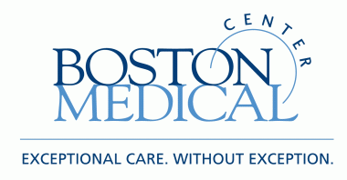



## Childcare Resources

Family Resource Book

Childcare Resources – Sample Handout

**Child Care Choices of Boston (CCCB)**

* Provides information to make the best decision for your child care needs
* Extensive database of Boston area child care centers

**Contact: 617.542.KIDS (5437)**

**105 Chauncy Street, 2nd Floor, Downtown Boston, MA 02111**

**Hours:** Monday to Friday 9:30AM-3:30PM

**Eligibility:** Open to all Parents

**Payment Source: FREE**

**Department of Early Education and Care (EEC)**

* Waitlist for vouchers now administered through CCCB (see below)
* If you need subsidized childcare but are **NOT currently receiving TAFDC**

**Contact: 617.348.6677**

**51 Sleeper Street, 4th Floor, Downtown Boston, MA 02210**

**Hours:** Monday to Friday call between 10AM and 2PM

**Eligibility:** Low-income families who are **NOT** eligible for TAFDC

**Payment Source: FREE**

**Early Head Start/Head Start**

* Enhances the development of young children and promotes healthy families
* Free childcare for children under age 3 in **Early Head Start program**
* Free childcare for children ages 3-5 in the regular **Head Start program**

**Contact:** Call **617.348.6272** to be directed to your neighborhood location

**178 Tremont Street, Downtown Boston, MA 02111**

**Hours:** Monday to Friday 9AM-5PM

**Eligibility:** Meet Annual Household Income Limits ($22,050 for a family of four)

**Payment Source: FREE**

**Department of Transitional Assistance (DTA)**

* Link to available childcare for those **already receiving TAFDC benefits**

**Contact:** Call **617.348.8500** and refer to your DTA case manager

**Hours:** Monday to Friday 9AM-5PM

**Eligibility:** Currently receiving TAFDC benefits through the DTA

**Payment Source: FREE**

**This list of resources was last updated on: MM/DD/YYYY.**

**For immediate needs or questions, please contact your child's doctor's office.**

## 

## BriefcaseEmployment Resources

Family Resource Book

Employment Resources – Sample Handout

**Boston Career Link**

* Provides access to a broad range of career counseling and training services
* Connects you directly to employers

**Contact:** Call **617.536.1888 ext. 560**

**1010 Harrison Avenue, Roxbury, MA 02119**

**Hours:** Monday, Thursday, Friday: 9AM-5PM; Tuesday: 9AM-7PM; Wednesday: 9AM-2:30PM

**Eligibility: Anyone**

**Payment Source: FREE**

**Operation ABLE**

* Provides individuals with training programs and employment services including occupational and computer training, job search training and support, counseling

**Contact:** Call **617.542.4180** or attend **Free information session** on Wednesdays at 10AM

**174 Portland St, 5th Floor, Boston, MA 02114**

**Eligibility: Anyone**

**Payment Source: FREE**

**Career Collaborative**

* Offers job search and job readiness courses
* Helps with job retention and career goals post-employment

**Contact:** Call **617.424.6616**

**77 Summer Street, 11th Floor, Downtown Boston, MA 02110**

**Hours:** Monday to Friday 8:30AM-5:30PM

**Eligibility: Anyone**

**Payment Source: FREE**

**This list of resources was last updated on: MM/DD/YYYY.**

**For immediate needs or questions, please contact your child's doctor's office.**

## 

## Housing Resources

Family Resource Book

Housing Resources – Sample Handout

**Boston Housing Authority**

* Provides applications **for all housing programs** in Boston
* Public, Subsidized, Section 8 Housing and Mass Residential Vouchers
* Links your family to the appropriate state or federal program

**Contact:** Call **617.988.4200**

**56 Chauncy Street, Downtown Boston, MA 02111**

**Hours:** Monday to Friday call between 9AM and 5PM

**Eligibility:** Annual household income 80% of the median average ($64,000 for a family of four)

**Bring:** Proof of ID (license), income (pay stubs), expenses (childcare receipt)

**Payment Source: FREE**

**Traveler’s Aid Family Services**

* Places your family in appropriate Boston area shelters

**Contact: 617.542.7286**

**727 Atlantic Avenue, Downtown Boston, MA 02111**

**Hours:** Monday to Friday call between 9AM and 5PM

**Eligibility:** Low-income families who are **NOT** eligible for TAFDC

**Payment Source: FREE**

**Action for Boston Community Development (ABCD)**

* Helps with filling out Boston Housing Authority Applications
* Provides workshops to navigate the housing application process
* Staff available to answer your questions
* Assists in gathering required documents

**Contact:** Call **617.348.6347**

**178 Tremont Street, 3rd Floor, Downtown Boston, MA 02111**

**Hours:** Monday to Friday call between 9AM and 5PM

**Eligibility:** Anyone

**Payment Source: FREE**

**This list of resources was last updated on: MM/DD/YYYY.**

**For immediate needs or questions, please contact your child's doctor's office.**



## Food Resources

Family Resources Book





Food Resources – Sample Handout

**Project Bread Food Hotline**

* Will direct you to local food pantries and emergency food locations

**Contact:** Call **1.800.645.8333**

**Hours:** Monday to Friday call between 8AM and 7PM; Saturday call between 10AM and 2PM

After hours call the Mayor’s Hotline: **617.635.4500**

**Eligibility: Anyone**

**Payment Source: FREE**

**Supplemental Nutrition Assistance Program (SNAP)—Food Stamps**

* Provides Electronic Benefits Transfer (EBT) Card to be used as a debit card

**Contact:** Call **617.989.6000**

**Dudley Square Department of Transitional Assistance**

**2201 Washington Street, Roxbury, MA 02119**

**Hours:** Monday to Friday 9AM-5PM

**Eligibility:** Meet monthly household income limits ($3,675 for a family of four)

**Payment Source: FREE**

**Women Infants and Children (WIC)**

* Provides checks to buy free, healthy food for you and your children birth to age five

**Contact:** Call **617.825.0805 (Dorchester House Multiple Service Center)**

**1353 Dorchester Avenue, Dorchester, MA 02122** OR

Call: **617.822.5584 (Main WIC Office)**

**632 Blue Hill Avenue, Dorchester, MA 02121**

**Hours:** Monday, Tuesday, Thursday, and Friday: 8:30AM-4PM; Wednesday: 11AM-4PM

**Eligibility:**

* Meet Annual Household Income Limits ($40,793 for a family of four)
* If you receive TAFDC, Medicaid or SNAP benefits you are **automatically eligible**
* Does **NOT** affect immigration status

**Bring:** Proof of ID (license), income (pay stubs), MA resident (mail/utility bill)

**Payment Source: FREE**

**This list of resources was last updated on: MM/DD/YYYY.**

**For immediate needs or questions, please contact your child's doctor's office.**

## 

## Education Resources

Family Resource Book

Education Resources – Sample Handout

**Massachusetts Adult Literacy Hotline:**

* Provides contact information on GED preparation classes in your neighborhood

**Contact:** Call **1.800.447.8844**

**Eligibility:** Anyone

**Payment Source: FREE**

**College Bound Dorchester—Adult Basic Education**

* Prepares you for the GED through advising and coursework
* Additional courses can assist you in advancing to college

**Contact:** Call **617.506.5970 (Adult Ed)** or **617.282.5034 (Main number)**

**18 Samoset Street, Dorchester, MA 02124**

Alternative location: **222 Bowdoin Street, Dorchester, MA 02122**

**Hours:** Monday to Friday 9AM-5PM

**Eligibility Anyone:**

**Payment Source: FREE**

**ABCD- Learning Works**

* Young Parents Program provides GED prep
* Individualized counseling and support

**Contact:** Call **617.357.7453**

**178 Tremont Street, Downtown Boston, MA 02111**

**Hours:** Call Monday to Friday 9AM-5PM to enroll

**Eligibility:** 16-21 year old parents and expectant parents

**Payment Source: FREE**

**This list of resources was last updated on: MM/DD/YYYY.**

**For immediate needs or questions, please contact your child's doctor's office.**



## Utilities Resources

Family Resource Book



Utilities Resources – Sample Handout

**ABCD Fuel Assistance Program (LIHEAP)**

* Help to pay winter heating bill by working with fuel providers
* Program runs from November 1st to April 30th

**Contact:** Call **617.357.6012**

**178 Tremont St, 4th Floor, Downtown Boston, MA 02111**

**Hours:** Monday to Friday 9AM-5PM

**Eligibility:** Meet annual household income level ($56,011 for a family of four)

**Bring:** Proof of ID, income, current heating bill, social security card

*If you do not have a social security card, bring your passport and request state funds*

**Payment Source: FREE**

**NSTAR Discount Rate Program**

* Discount rate of 25% off bills, retroactive rate, and shutoff protection

**Contact:** Call **1.800.592.2000**

**Hours:** Monday to Friday call between 8:30AM- 5PM to request an application

* Fill out application and either mail or fax to following address:

**NSTAR/Customer Service, One NSTAR Way NW200, Westwood, MA 02090**

**Fax: 781.441.8512**

**Eligibility:** Already receiving a government subsidy (i.e. TAFDC, SNAP, Head Start/ Early Head Start)

**Bring:** Verification that you receive a government subsidy (i.e. TAFDC, SNAP, Head Start/ Early Head Start)

**Citizens Energy Corporation: JOE-4-SUN**

* Eligible households can receive discounts of up to $300 on electricity bill

**Contact:** Apply at <https://citizensenergy.com/joe4sun-massachusetts> or call **855.563.4786**

**Eligibility:** Be a low-income discount customer of either Eversource or National Grid

**Documents required:** Digital copy of your most recent electricity bill and a valid email address

**Payment Source:** FREE

**This list of resources was last updated on: MM/DD/YYYY.**

**For immediate needs or questions, please contact your child's doctor's office.**

Spine Labels

**1.5 to 2 inch binder:**



**Family Resource Book**



**Family Resource Book**



**Family Resource Book**



**Family Resource Book**

**1 inch binder:**



**Family Resource Book**

**Family Resource Book**

**Family Resource Book**

**Family Resource Book**