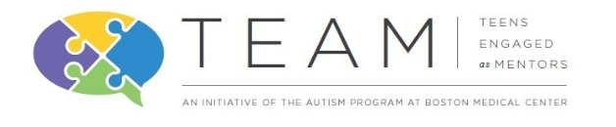 | TEAM (Teens Engaged as Mentors)  Mentor Application 2017-2018
Program Description:
TEAM (Teens Engaged as Mentors) will involve and encourage the participation and leadership of adolescents with and without autism. It will facilitate the social and development of both groups of students in addition to fostering learning, respect and understanding. The program’s structure will be that each mentor will work in a collaborative co-mentoring partnership. Mentor partners will work together to mentor a younger child between the age of 9-13. The program will run throughout the course of the academic year with a required training for all mentors and supervised monthly recreational events and community service opportunities.
PLEASE WRITE NEATLY OR TYPE.

Participant Information
Name: |  |  |  | Date:
 | Last | First | M.I.

Date of Birth: _______________________ Age: ____________________

Address:
 | Street Address | Apartment/Unit #

 | City | State | ZIP Code

Phone: |  | Email:

School Information
School Name:

Grade in school (2017-2018): ___________

Short Reponses

Please answer each question in a few sentences.

- Why do you want to be involved in this program?

- Do you think you will make a good leader? Why?

- In what ways have you been a leader before?

- What would you consider your greatest strength?

- What would you consider your greatest challenge?

- Please describe the ways you best communicate with others.

- What are you hoping to gain from the program? In other words, outline some goals.

- What are your interests or hobbies?

- Is there anything that you are afraid of?

- Where do you see yourself in 5 years?

- What are some activities that you would like to do through the TEAM program?

- Is there anything else you would like us to know about you?

Reference
Please provide a reference from a non-family member:
Name: |  | School:
Email: |  | Phone:
In what capacity do you know the applicant?
How long have you known the applicant?
Please tell us more about this applicant from your experience (highlighting the attributes that would make this applicant a good mentor):

Parent/Guardian Contact Info
Name: |  | Relationship:

Phone: |  | Email:

Signature/Consent to Participate:
PLEASE EMAIL COMPLETED FORMS to autismprogram@bmc.org OR mail to:
The Autism Program at Boston Medical Center
Vose 412
72 E Concord St.
Boston, MA 02118

APPLICATION DEADLINE: September 15, 2017

