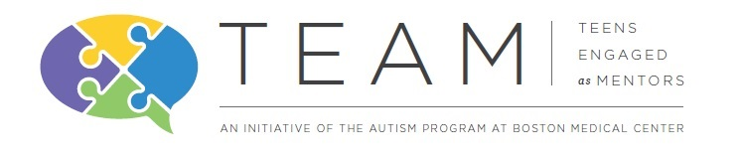
The Autism Program at Boston Medical Center is seeking MENTORS and MENTEES for an innovative program
Teens Engaged as Mentors (TEAM)

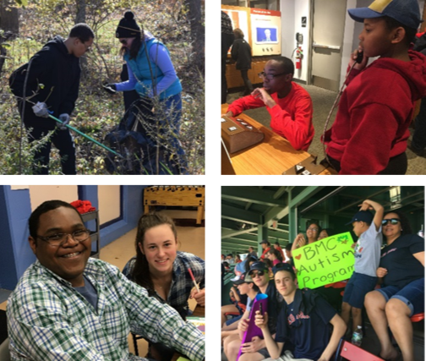
The BMC Autism Program's teen mentoring initiative, TEAM, empowers diverse children and adolescents using a unique mentorship model to facilitate strong leadership, self-confidence, and social skills development. Adolescents with and without ASD work together to mentor younger children on the autism spectrum. The program runs throughout the course of the academic year with required trainings for all mentors and supervised monthly recreational events and community service opportunities.

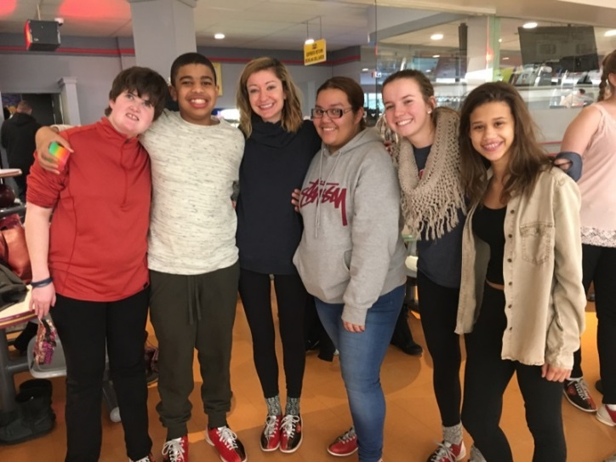
Past TEAM events have included:
- Attending a Red Sox game
- Arcade games, bowling & pizza at Boston Bowl
- Trail cleanup at the Boston Nature Center
- Donation projects for Boston Senior Home Care, BMC Child Protection Team, and the MSPCA
- Visiting the Museum of Science & MIT Museum
- Jumping at Sky Zone Everett trampoline park
- Rock climbing & basketball at BU FitRec Center
The Autism Program at Boston Medical Center | autismprogram@bmc.org | 617-414-3842
bmc.org/pediatrics-autism-program/services/teens-engaged-mentors-team facebook.com/TeensEngagedasMentors

PLEASE WRITE NEATLY OR TYPE. APPLICATION DEADLINE: August 1, 2018
Email completed forms to autismprogram@bmc.org OR mail to:
The Autism Program at Boston Medical Center
72 East Concord Street, Vose 412
Boston, MA 02118

Program Guidelines
- TEAM events are once per month on weekends during daytime hours. Participation at all events is required, and participants should always plan to arrive and leave on time.
- Clear communication is very important for event planning. Participants/parents should make every effort to respond to TEAM communications in a timely manner. These might include RSVPs to events, sharing important information about participants, or completing forms that are needed prior to events.
- Parents do not participate in TEAM events (unless otherwise specified) but are responsible for getting their child to and from each event.
- Events are free of cost to participants (not including cost of travel) and accessible by public transportation.
- A parent night will be held in the fall before the program begins. Parent attendance is mandatory for participation in the program.
- There will be a fall and spring training that is mandatory for all mentors accepted into the program.

I acknowledge that I have read and agree to these guidelines and give my consent for participation in TEAM.
Participant Signature | Date
Parent Signature | Date

What role are you applying for?
☐ Mentor: High school or post-secondary students with and without autism spectrum disorder (Ages 14-21)
☐ Mentee: Elementary/middle school students with autism spectrum disorder (Ages 9-13)
☐ Not sure: These age ranges are meant to provide a guideline for participant groups – depending on skills and goals for the program, participants may fit better in the group that doesn’t match their age.
PLEASE NOTE: Participants should not require 1:1 staffing or engage in aggressive or self-injurious behavior.

How did you hear about TEAM?
☐ Autism Program staff:
☐ Social media/Website/Online research
☐ Listserv email
☐ Resource fair/In-person recruiting
☐ Referred by: Role/Relationship:

Participant Information
Name:
 | Last | First | M.I.

Date of Birth: |  | Age:

Address:
 | Street Address | Apartment/Unit #

 | City | State | ZIP Code

Phone: |  |  |  | Email:
Preferred method of contact: |  | ☐ Phone call | ☐ Text message |  |  | ☐ Email | ☐ Contact parent

Parent/Guardian Information
Name: |  | Relationship:

Phone: |  |  | Email:
Preferred method of contact: |  | ☐ Phone call |  | ☐ Text message | ☐ Email

Emergency Contact Information
Name: |  | Relationship:

Phone:

School Information
School Name: |  | Grade in school (2017-2018):

Best school contact (teacher, guidance counselor, other staff):

Phone: |  | Email:

Consent to contact school for consultation/data collection:
 | Signature (Parent or Applicant if over 18) | Date

Short Reponses

Please answer each question with a short response. We encourage participants to give as much information as possible independently, but any help from a family member, school staff, etc. is welcomed.

- Why do you want to be involved in this program?

- What are some of your strengths?

- What are some of your challenges?

- What are your interests or hobbies?

- How do you best communicate with others?

- How do you let people know when you’re feeling upset or frustrated? Are there things that help you calm down?

- What are you hoping to gain or accomplish from being in the program?

- What are some activities that you would like to do through TEAM?

- Is there anything else you would like us to know?

Reference

Please provide a reference from a non-family member:
Name: |  | Title/Role:

Phone: |  | Email:

In what capacity do you know the applicant?

How long have you known the applicant?

Please tell us more about this applicant from your experience (highlighting the attributes that would make this applicant a good TEAM participant):

