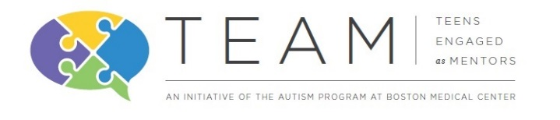
TEAM (Teens Engaged as Mentors)
Mentee Referral 2016-2017
Name: Age:

School: Grade of child (in Sept. 2016):

Primary Contact:

Phone:

Email:

The following questions are all optional and are meant to give us an idea of how we can best support this child in their success with TEAM.

- Does this child have a diagnosed disability?
- What are his/her strengths:
- Does he/she receive any therapies or services? Please list.

Interests:
What activities does he/she most enjoy?

What activities does he/she least enjoy?

What are the best ways to communicate with/deescalate the child?

Behavior:
Does he/she have any challenging behaviors that we should be aware of?

If so, what is likely to trigger these behaviors? (ex: change in schedule; noise, etc)

How does he/she express being upset? Overwhelmed? Frustrated?

What are some things that are calming?

Goals:
What do you hope to see him/her accomplish through TEAM?

Is there anything else you would like us to know?

Parent/Guardian Contact Info
Name: |  | Relationship:

Phone: |  | Email:

Signature/Consent to Participate:
PLEASE EMAIL COMPLETED FORMS to autismprogram@bmc.org
OR mail to: The Autism Program at Boston Medical Center
Vose 412
72 E Concord St.
Boston, MA 02118

