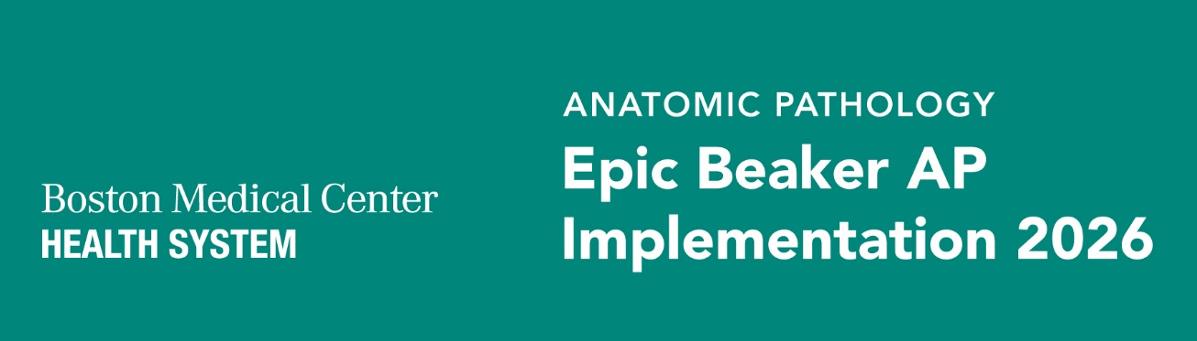
Epic Beaker AP Newsletter #7 | October 2026
WHAT YOU NEED TO KNOW
- Reminder for Scope: Epic Beaker AP will support orders, specimen collection and results related to Anatomic Pathology, including biopsies, Pap smears, and other tissue-based specimens. Clinical Pathology (CP) workflows, such as swabs, blood draws, urine dipstick and stool samples are not included in this phase and will continue to use Sunquest.
- Devices and Testing: Device installation and testing are underway across impacted clinical areas across the health system. Technical Dress Rehearsal (TDR) is validating devices and workflows in the clinical environment. Printer placement and accessibility continue to be reviewed to support specimen collection and labeling. Please order label stock ASAP: Specimen Label Order for Epic Beaker AP.docx​​.
- We are excited to have completed our 30-Day Go-Live Readiness Assessment (GLRA), marking another important milestone as we enter the final stage of our Epic Beaker AP implementation. Thank you to everyone for your continued collaboration and dedication as we prepare for a successful go live.
- End-user training is officially underway! All assigned Epic Beaker training should be completed within the designated training window. Training is a critical component of go-live readiness, ensuring that users have the resources needed to confidently transition to Epic Beaker beginning November 2.
- As we prepare for the November 2 Epic Beaker AP go-live, upcoming Life of a Specimen sessions will walk staff through future-state specimen workflows across inpatient, procedural, and ambulatory settings. These sessions will help reinforce key workflow changes and prepare teams for go-live. There will be a session at each hospital site.
Wet Testing
Wet testing represents a major October milestone as we enter the final stages of our Epic Beaker AP implementation. Our teams have made significant progress in preparing for go-live, with CCV Phase 2 dry testing now 100% complete across Histopathology, GYN/Non-GYN Cytology, Molecular Diagnostics/Molecular Genetics, and Flow Cytometry. Building on this accomplishment, our focus now shifts to laboratory wet testing, which will meet regulatory need to validate workflows using real-world laboratory processes and confirm that our teams and systems are prepared for go-live. From October 5 through October 23, laboratory managers, medical directors, subject matter experts, and project team members will work collaboratively toward completing 100% of planned wet testing scenarios. The continued engagement and collaboration of our laboratory teams will be essential as we move closer to our go live.
IMPORTANT DATES & UPCOMING ACTIVITIES
Date | What’s Happening
9/28 – 10/23 | End User Training
10/24 – 11/1 | Remediation training in the form of 1:1 coaching, hands on practice, added review
10/31 – 11/2 | Cutover / Epic Beaker AP Go-Live
At-The-Elbow support will be available throughout the first two weeks of go-live, with continued ATE designated support in week three to help staff navigate new Epic Beaker workflows. In-person support is planned at BMC Main, South, Brighton, DotHouse, and Codman, as well as ambulatory AP specimen collection areas. The command center will be operational, taking calls and triaging tickets. Please reach out as needed.
If you currently use these forms you will need to attend training:
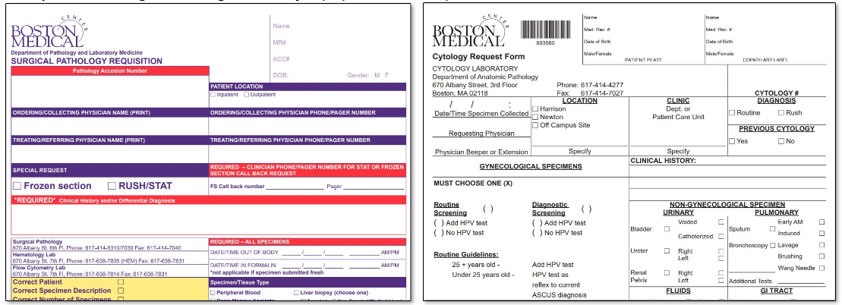
You may self-assign training in Workday at Epic Beaker Clinician Specimen Collection - MD, APP – Workday
RESOURCES & QUESTIONS
- Epic Beaker AP project page: Epic AP Beaker Implementation 2026 | Boston Medical Center
- General implementation questions: pete.balestracci@bmc.org
- Training / resources questions: vickie.wagner@bmc.org
- Lab related questions: liam.donovan@bmc.org
- Here are your department ambulatory champions: Thank you everyone! Beaker AP Operational Readiness Champions.pptx​
Laboratory Medicine Update

