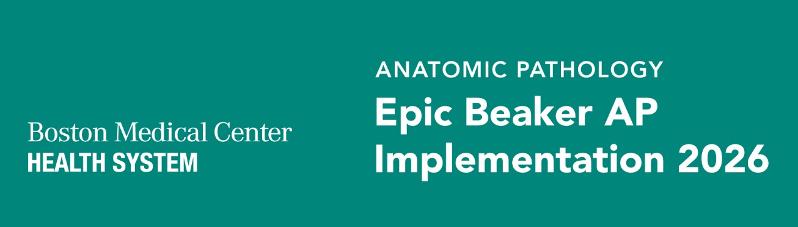
Epic Beaker AP Newsletter #6 | September 2026
WHAT YOU NEED TO KNOW
- We are excited to welcome Grace Owen as our new Epic Application Manager! Grace brings extensive Epic Beaker implementation and change management experience. We look forward to her leadership and contributions as we continue toward a successful go-live!
- Leadership participated in the 60-Day Go-Live Readiness Assessment (GLRA), gaining insight into build progress, training plans, and overall readiness. The session supported leadership alignment and preparation for a successful Epic Beaker go-live!
- Epic Beaker-compatible hardware, including scanners if needed and printers with initial label stock, will be installed at all applicable locations. The EUD teams are now reaching out to schedule install time per area. Please note that existing printers will not print the necessary anatomic pathology labels.
Training Readiness
Training preparation continues to advance as we move closer to Epic Beaker AP go-live. The project team is actively validating training curriculum and workflows against the BMC Epic build and incorporating updates identified through ongoing workflow validation. Work is also underway to finalize specimen collection content across non-laboratory pathways, confirm training requirements for registration staff, and finalize the overall training approach for impacted non-laboratory teams.

As training approaches, leaders and managers are encouraged to begin reinforcing the training timeline and expectations with their teams through staff meetings, huddles, and other department communications. Staff should be reminded to watch for their individual training assignments and complete all required training. Leaders will play an important role in supporting staff throughout the training process, addressing questions or barriers, and monitoring training completion. Readiness and completion reporting will continue to be reviewed, with follow-up occurring as needed to help ensure teams are prepared and confident ahead of go-live.
IMPORTANT DATES & UPCOMING ACTIVITIES
Date | What’s Happening
9/21 – 9/25 | Super User and Subject Matter Expert Training
9/28 – 10/23 | End User Training
10/24 – 11/1 | Remediation in the form of 1 on 1 coaching, hands on practice, additional review
Training schedules have been updated to align with the latest implementation timeline and ensure teams are prepared for upcoming activities. Training remains a key part of go-live readiness. Additional details on registration, schedules, assignments, expectations, and resources will be shared as finalized. Please watch for upcoming training communications as we approach go-live.

If you currently use these forms you will need to attend training:
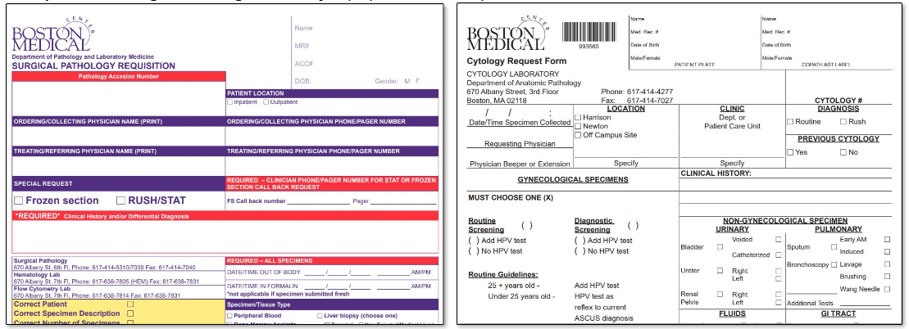
RESOURCES & QUESTIONS
- Epic Beaker AP project page: Epic AP Beaker Implementation 2026 | Boston Medical Center
- General implementation and hardware questions: pete.balestracci@bmc.org
- Training / resources questions: vickie.wagner@bmc.org
- Lab related questions: liam.donovan@bmc.org
Laboratory Medicine Update

