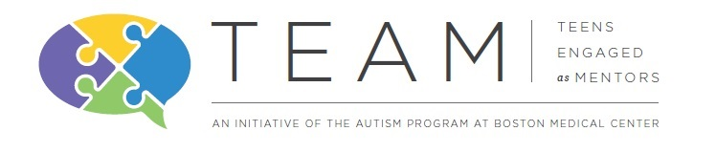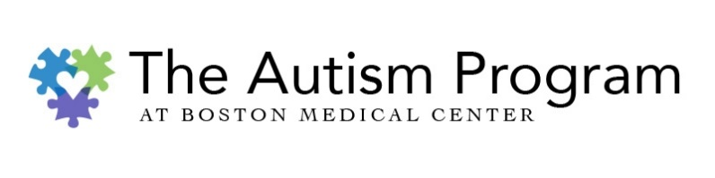

**The Autism Program at Boston Medical Center** is seeking **mentors and mentees** for an innovative program.

**Now accepting applications for** 2023-2024!

Teens Engaged as Mentors (TEAM)

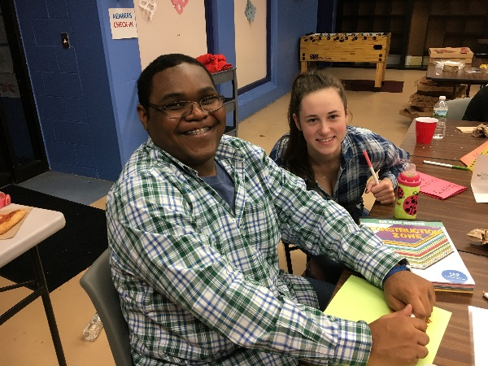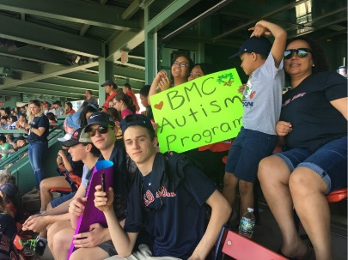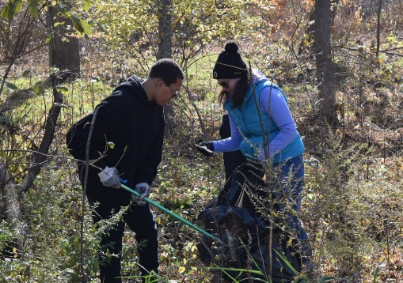

Events are once per month on weekends during daytime hours.

Participation at all events is required.

All events are staffed by trained facilitators through Boston Medical Center.

Parents do not participate but are responsible for their child’s transportation.

This program is free of cost to participants.

**Mentors**

* High school/post-secondary students with and without autism spectrum disorder (Ages 14-21)

**Mentees**

* Elementary/middle school students with autism spectrum disorder (Ages 9-13)

Participants should not require 1:1 staffing or engage in aggressive or self-injurious behavior.

All mentors will receive training and supervision at the start of the program.

**Please see our website for more information about participant requirements.**

**Past TEAM events have included:**

* Attending a Red Sox game
* Arcade games, bowling, and pizza at Boston Bowl
* Trail cleanup at the Boston Nature Center
* Donation projects for Boston Senior Home Care, BMC Child Protection Team, and the MSPCA
* Visiting the Museum of Science & Aquarium
* Pottery Painting at the Clayroom in Brookline
* Rock climbing & Roller skating

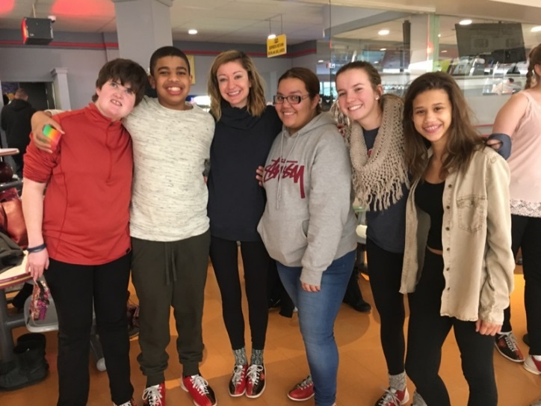

***Application Period:*** *June 1st 2023 – September 1st 2023*

***Program Runs:*** *September 2023 – June 2024*

If you or someone you know is interested in being involved with TEAM, either as a mentor or mentee, please contact us at [autismprogram@bmc.org](mailto:autismprogram@bmc.org) or (617) 652-0320.

Or, visit our website for more information and to complete an application!

[www.bmc.org/pediatrics-autism-program/services/teens-engaged-mentors-team](http://www.bmc.org/pediatrics-autism-program/services/teens-engaged-mentors-team)