Points of Contact: | Connor Walton, MPH: 804-338-8234  Alexandra Weddell, MBA: 508-493-3177  Christian Arbelaez, MD, MPH: 617-816-0310
Hotel Location: | Fairmont Copley Plaza Hotel  138 St. James Ave, Boston, MA 02166  (617) 267-5300  https://www.fairmont.com/copley-plaza-boston/
Transportation: | A shuttle will be available for arrivals and departures on Thursday, June 1st and Saturday, June 3rd  - Airport Arrivals (June 1st): The shuttle will be located at Terminal B, Level 1 Parking Area (see map below for reference). The shuttle will leave every hour on the hour beginning at 1pm until 12am midnight. Please look for a white mini bus with the LEED Conference logo on each side.  - Attendees arriving at Terminal A will need to take airport shuttle route #11, #22, or #88 to reach Terminal B  - Attendees arriving at Terminal C can walk to Terminal B via the connected walkway or take airport shuttle route #11, #22, #88.  - Shuttle to BMC Campus (June 3rd): A shuttle to BMC will be located at the Fairmont Copley Plaza’s Trinity Place entrance, departing at 8:30am  - Airport Departures (June 3rd): The first shuttle from BMC to Boston Logan Airport will depart at 11:00am and run hourly. Attendees will board the shuttle at 85 E. Concord St.  Ubers are also available to/from Boston Logan Airport  For shuttle issues, please contact Connor Walton
Parking: | The Fairmont Copley Plaza offers valet parking for individuals driving to Boston. Please inform the valet that you are with BMC and your parking will be covered by the LEED conference
Conference Location: | Friday, June 2nd  Fairmont Copley Plaza Hotel  Basement Level  State Suite A & B | Saturday, June 3rd  Boston Medical Center  FGH Building  820 Harrison Ave
Conference Attire: | Business Casual is recommended. Please bring layers as the conference rooms may vary in temperature.

Agenda at a Glance: | Thursday, June 1  Check In at Hotel: 4:00pm (rooms may be available earlier)  Cocktail Reception: 7:00pm – 10:00pm  - Sonsie  327 Newbury St, Boston, MA 02115  (617) 351-2500  https://www.sonsieboston.com/  Friday, June 2  Breakfast: 8:00am – 9:00am  - State Suite  Conference: 9:00am – 5:00pm  Networking Dinner: 6:00pm – 10:00pm  - Porto  Ring Rd, Boston, MA 02199 (adjacent to the Prudential Center)  (617) 536-1234  https://www.porto-boston.com/  Saturday, June 3  Breakfast: 8:00am – 8:30am  - Check Out for the hotel is 11am. However, we ask that attendees departing on 6/3 check out before traveling to BMC. Luggage will be stored in a secure area on campus for the half-day portion of the conference.  Travel to BMC: 8:30am – 8:45am  Conference: 9:00am – 1:30pm  Hourly shuttle service to airport begins: 11:00am  Optional Tour of BMC ED: 1:30pm – 2:00pm

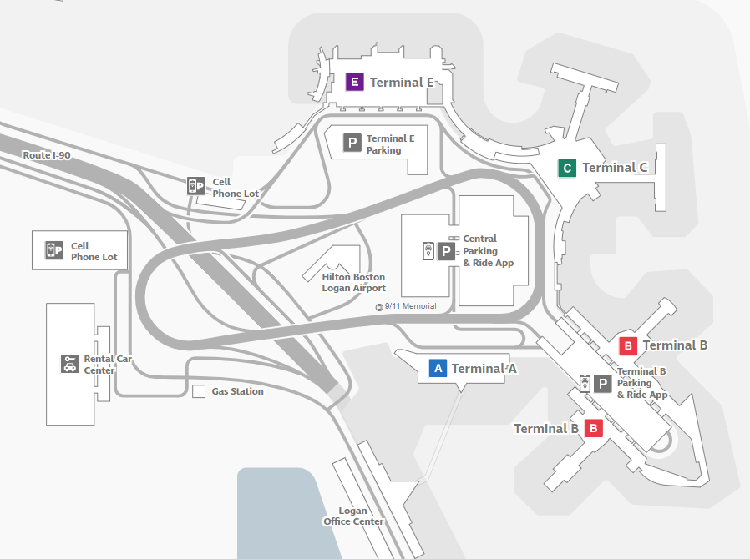
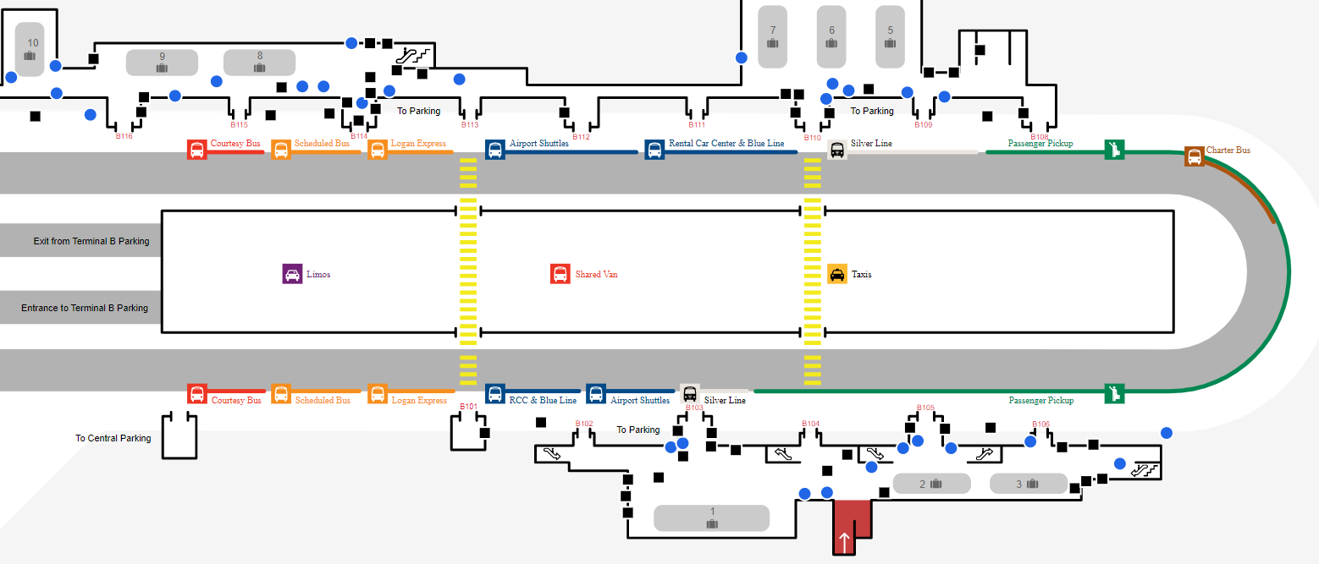
Terminal B, Level 1 (Shuttle location noted with )
Boston Logan Airport

