

Boston Medical Center

Credit and Collection Policy

**August 30, 2021**

Effective: October 1, 1998 Reviewed and approved by the Board of Trustees Finance Committee: October 27, 1998

Approved by the full Board of Trustees: December 2, 1998 Preliminary filing with the Division of Health Care Finance and Policy: December 3, 1998

Revised: September 22, 1999

Revised: August 9, 2005

Revised: April 28, 2006

Revised: January 1, 2009

Revised August 20, 2014 Reviewed and Approved by Board of Trustees Finance Committee August 26, 2014

Submitted to Health Safety Net: September 2, 2014

Approved by the Board of Trustees: November 11, 2014

Revisions approved by the Board of Trustees: May 12, 2015

Submitted to Health Safety Net: May 18, 2015

Revised: August 30, 2021

# Table of Contents

Policy Statement / Definitions 1

1. Delivery of Health Care Services 7
2. Verification of Coverage for Hospital Services 9
3. Financial Assistance and Program Eligibility 9
4. Hospital Collection Practices 10
5. Deposits and Installment Plans 17
6. Patient Assistance Resources 18

Attachments/Exhibits 20

Exhibit 1A Financial Assistance Brochure - English

Exhibit 1B Financial Assistance Brochure - Spanish

Exhibit 1C Financial Assistance Brochure – Haitian Creole

Exhibit 1D Financial Assistance Brochure – Portuguese Creole

Exhibit 2 Sample Patient Statement, Notification of FAP

Exhibit 3 Sample Hospital Sign, Notification of FAP

Exhibit 4 BMC Provider List

Exhibit 5 BMC Financial Assistance Approval Letter

Exhibit 6 BMC Financial Assistance Denial Letter



|  |  |
| --- | --- |
| **Policy #:** | 08.26.000 |
| **Issued:** | 10/1998 |
| **Reviewed:** | 9/1999, 8/2005,4/2006, 1/2009,  11/2014 |
| **Revised:** | 5/2015, 8/2021 |
| **Section:** | Fiscal Management |

**Credit and Collection Policy**

**Purpose:**

Boston Medical Center, (the “Hospital” or “BMC”), developed this policy in alignment with its mission to provide consistently excellent and accessible services to all, particularly vulnerable populations, in an ethically and financially responsible manner to meet its fiduciary responsibility to appropriately bill and collect for medical services provided to patients. Boston University Medical Group, (BUMG), as a collaborative partner of BMC, agrees to adhere to the established guidelines set forth in the Hospital’s Financial Assistance Policy and Credit and Collection Policy.

**Policy Statement**:

It is the policy of BMC, BUMG, and the Hospital’s licensed Community Health Centers to provide medically necessary care to all patients, regardless of their ability to pay, and to offer financial assistance to those who are uninsured or under-insured and cannot pay. All patients who present to BMC and require emergent or urgent services, or other medically necessary care, shall be treated regardless of race, color, religion, creed, sex, national origin, age, disability, gender identity or expression, or ability to pay.

BMC offers financial assistance programs to all low-income, uninsured or under-insured, patients who demonstrate an inability to pay for all, or some portion of, charges normally due. Patients requesting assistance will be screened for eligibility and coverage under Medicaid or other state programs, Qualified Health Plans, or may be evaluated against pre-established guidelines to determine eligibility for assistance under the Hospital’s Charity Care Program, (CCP). A determination of eligibility under a state or federal financial assistance program may cover some or all a patient’s unpaid hospital bill. Patients found ineligible for state or federal financial assistance programs may be reevaluated for free or discounted care under the hospital’s CCP. The level of discount offered under the CCP to qualifying patients is determined by household income, assets, family size, and medical needs as specified in the eligibility guidelines. For patients with private insurance plans, the Hospital is required to work through the insurance payor to determine what may be covered under the patient’s policy.

All patients may request and be considered for financial assistance at any time during the billing and collection cycle.

**Application:**

This Credit and Collection policy, which applies to the hospital and any entity that is part of the hospital’s licensure or tax identification is reviewed and updated on a regular basis by the appropriate persons at Boston Medical Center. This policy is presented and approved by the Finance Committee of the Board of Trustees Committee and submitted to the Health Safety Net Office. The Hospital’s Credit and Collection Policy is available to patients upon request by contacting Patient Financial Counseling at 617-414-5155, or for download by visiting <https://www.bmc.org/services/patient-financial-assistance>.

**Exceptions:**

None

**Definitions:**

**Amounts Generally Billed (AGB)** - The amount by which charges for Uninsured patients are measured. Uninsured patients will not be charged more for Emergency Services, Urgent Services, or other Medically Necessary care than the AGB for patients who have insurance coverage. To calculate AGB, BMC uses the look-back method which utilizes data from Medicaid payments, based on the prior 12-month fiscal year, to determine the AGB percentage to be applied to charges. The AGB percentage utilized by BMCHS, and the method in which it was determined is available, free of charge, from the Patient Financial Counseling, (PFC), and Department. Requests may be made by calling PFC at 617-414-5155 or by emailing DG-FinancialCounseling@bmc.org.

**Certified Application Counselor (CAC)** - An individual (affiliated with a designated organization) who is trained and able to help consumers, small businesses, and their employees review ACA compliant, health coverage options, offered through the Health Insurance Marketplace, and assist with the determining eligibility and completing enrollment forms.

**Charity Care Program, (CCP)** - A financial assistance program offered by Boston Medical Center that offers a percentage discount on the patient’s account balance based on the patient’s ability to pay and a determination of program eligibility as specified by the hospital’s Financial Assistance Policy.

**Coinsurance** – A percentage of medical cost owed by the insured after meeting the deductible. Coinsurance is a way of saying the insurance holder and insurance carrier each pay a share of eligible costs that add up to 100 percent of the policy.

**Collection Action-**  As defined in 101 CMR 613.02, Any activity by which a Provider or designated agent requests payment for services from a Patient, a Patient’s guarantor, or a third party responsible for payment. Collection Actions include activities such as preadmission or pretreatment deposits, billing statements, collection follow-up letters, telephone contacts, personal contacts, and activities of collection agencies and attorneys.

**Copay** - a fixed out-of-pocket amount paid by the insured for covered services under a health insurance plan. Copays are often charged for services such as doctor visits or prescription drugs on the same date of service.

**Deductible –** the amount paid out of pocket by a policy holder for healthcare expenses before the health insurance company will begin to make payment on medical claims.

**Elective Services (Non-Emergent, Non-Urgent Services)** - Medically necessary services that do not require care or treatment from an emergency department or acute hospital for medical stabilization, and therefore, do not meet the definition of emergent or urgent services. The patient typically, but not exclusively, schedules such services in advance.

**Emergency Services** - Medically necessary services provided after the onset of a medical condition, whether physical or mental, manifesting itself by symptoms of sufficient severity including severe pain, that the absence or omission of prompt medical attention could reasonably be expected to adversely affect the condition or health of the person, resulting in serious jeopardy, impairment, or dysfunction of any body part or bodily organ, with respect to a pregnant woman, as further defined in section 1867(e) (1) (B) of the Social Security Act, 42 U.S.C. § 1295dd(e)(1)(B). Emergent Services include a medical screening examination and treatment for emergency medical conditions, or any other such service rendered to the extent required pursuant to EMTALA (42 USC 1395(dd)) Emergent Services also include: services determined to be an emergency by a licensed medical professional; Inpatient medical care which is associated with the outpatient emergency care; and Inpatient transfers from another acute care hospital to BMC for the provision of inpatient care that is not otherwise available at the transferring hospital.

**EMTALA** - Emergency Medical Treatment & Labor Act (EMTALA), a law enacted by Congress in 1986 to ensure public access to emergency services regardless of one’s ability to pay. Section 1867 of the Social Security Act imposes specific obligations on Medicare-participating hospitals that offer emergency services to provide a medical screening examination when a request is made for examination or treatment for an emergency medical condition, including active labor, regardless of an individual's ability to pay. Hospitals are then required to provide stabilizing treatment for patients with EMCs. If a hospital is unable to stabilize a patient within its capability, or if the patient requests, an appropriate transfer should be implemented.

**Federal Poverty Guidelines (FPG)** - Determined by the government of the United States and published annually in the Federal Register. FPG are based on the size of a family and family’s income and is used in determining a patient’s eligibility for financial assistance under state Medicaid programs and BMC’s Financial Assistance Policy.

**Financial Assistance Program** - A Financial Assistance Program is one that is intended to assist low-income patients who do not otherwise have the ability to pay for their health care services. Such assistance should consider each individual’s ability to contribute to the cost of his or her care. Consideration is also given to patients who have exhausted their insurance benefits and/or who exceed financial eligibility criteria but face extraordinary medical costs. A financial assistance program is not a substitute for an employer-sponsored, a public financial assistance, third-party liability or an individually purchased insurance program.

**Gross Charges** – The full, established price for medical care that the Hospital consistently and uniformly charges all patients before contractual allowances, discounts, or other deductions are applied.

**Health Care Services** - Hospital level services (provided in either an inpatient or outpatient setting) that are reasonably expected to prevent, diagnose, prevent the worsening of, alleviate, correct, or cure conditions that endanger life, cause suffering or pain, cause physical deformity or malfunction, threaten to cause or to aggravate a handicap, or result in illness or infirmity.

**Health Safety Net (HSN)** – The Health Safety Net is a financial assistance program, established and administered in accordance with M.G.L.c. 118E Section 8A, that pays for certain medically necessary services provided to qualified, low-income patients at Massachusetts’ community health centers (CHCs) and acute care hospitals. The HSN also pays CHCs and acute care hospitals for medical hardship expenses (when qualifying medical expenses exceed a specified percentage of a family's income), and for some types of hospital bad debt. HSN was created to distribute the cost of providing uncompensated care more equitably to low-income, Massachusetts’ residents through the offering of free or discounted care across acute hospitals in the state. The Health Safety Net pooling of uncompensated care is accomplished through an assessment on each hospital to cover the cost of care for uninsured and underinsured patients with incomes under 300% the federal poverty level. It is the hospital’s policy that all patients who receive financial assistance under the hospital’s Financial Assistance Policy include the Health Safety Net assistance as part of the uncompensated care provided to low income patients.

**Insured** - The status of a patient with insurance or third-party coverage which pays all or a portion of the patient’s Gross Charges for medical services. This category includes those patients covered by a governmental payors such as Medicare, Medicaid, Champus, and authorized Veteran’s benefits; as well as private payors such as Medicare Advantage, Medicaid managed care organizations, commercial or managed care, auto and worker’s compensation.

**Medically Necessary** **Services** - Services that are reasonably expected to prevent, diagnose, prevent the worsening of, alleviate, correct, or cure conditions that endanger life, cause suffering or pain, cause physical deformity or malfunction, threaten to cause or to aggravate a disability, or result in illness or infirmity. Medically Necessary services include inpatient and outpatient services as authorized under Title XIX of the Social Security Act. However, a classification of Medically Necessary does not infringe or encompass the classification of Emergent Services or the EMTALA laws associated with that designation.

**Primary or Elective Care Services** – Medical care that is not an Urgent Care Service and is required by individuals or families for the maintenance of health and the prevention of illness. Primary Care consists of health care services customarily provided by general practitioners, family practitioners, general internist, general pediatricians, and primary care nurse practitioners or physician assistants. Primary Care does not require the specialized resources of an Acute Hospital emergency department and excludes Ancillary Services and maternity care services.

**Qualified Health Plans** - An insurance plan, certified by the Health Insurance Marketplace, that provides essential health benefits, follows established limits on cost-sharing (like deductibles, copayments, and out-of-pocket maximum amounts), and meets other requirements under the Affordable Care Act.

**Self-Pay Discount** - A percentage discount of the patient’s self-pay, account balance based on the patient’s Uninsured status. BMC offers uninsured patients a Self-Pay Discount based on the most recent calculation of AGB.

**Underinsured** - The status of patient who has some form of health insurance that does not provide adequate financial protection, resulting in the patient’s inability to cover out-of-pocket, health care expenses such as copays, coinsurance, and deductibles determined by the insurance provider and due from the patient for the delivery medical services.

**Uninsured** - The status of a patient that does not have any health insurance in effect for a specific date of service or where the patient’s coverage is not effective for a specific service due to network limitations, insurance benefit exhaust or other non-covered services.

**Urgent Care Services** - Medically necessary services provided after sudden onset of a medical condition, whether physical or mental, manifesting itself by acute symptoms of sufficient severity (including severe pain) that a prudent layperson would believe that the absence of medical attention within 24 hours could reasonably expect to result in: placing the patient’s health in jeopardy, impairment to bodily function, or dysfunction of any bodily organ or part. Urgent services are provided for conditions that are not life threatening and do not pose a high risk of serious damage to an individual’s health. Urgent Care Services do not include Primary or Elective Care.

**Procedure:**

# Delivery of Health Care Services

A. BMC provides care to all patients requiring Emergency Services, Urgent Services, other Medically Necessary services, and pregnant women in active labor regardless of their ability to pay. In accordance with the federal Emergency Medical Treatment and Active Labor Act (EMTALA) requirements, the Hospital will conduct a medical screening examination for all patients who present at a BMC location seeking Emergency Services to determine whether an emergency medical condition exists. The treating medical professional will determine if emergency or nonemergency services are needed by assessing the level of care and treatment needed, by applying standards of practice to patient’s presenting clinical symptoms. Determining the appropriate level of healthcare services to provide, is based on medical condition according to the definitions of Emergency Services, Urgent Care Services, and Non-Emergent, Non-Urgent Services.

# However, Non-emergent or non-urgent health care services, such as Elective Services and Primary Care Services, may be delayed or deferred if the Hospital is unable to verify active health insurance coverage for the scheduled date of service or screen for eligibility and initiate an application for a financial assistance program through MassHealth or Qualified Health Plans available through the Massachusetts’ Health Connector, Health Safety Net, or others. Choices related to the care delivery and service access are often defined in either the insurance carrier’s or the Hospital’s financial assistance program coverage manual.

# Determining the urgency of treatment will be made by a licensed medical professional, through an application of local standards of practice, national and state clinical standards of care, and the Hospital’s medical staff policies and procedures.

# The classification of patients’ medical conditions is for clinical management purposes only, and such classifications are intended for addressing the order in which physicians should see patients based on their presenting clinical symptoms. These classifications do not reflect evaluation of a patient's medical condition reflected in final diagnosis.

# All patients are able to seek emergency level services and urgent care services when they come to the Hospital emergency department or designated urgent care areas. However, patients with emergent and urgent conditions may also present in a variety of other locations, including but not limited to Labor and Delivery, ancillary departments, Hospital clinics and other areas. The Hospital also provides other elective services at the main Hospital, clinics and other outpatient locations.

# Verification of Coverage for Hospital Services

1. Patients are obligated to provide the Hospital with accurate and timely information regarding their full name, address, telephone number, date of birth, social security number (if available), and current health insurance coverage options, including any third party liability coverage resulting from a motor vehicle or worker’s compensation claim. The information is used to verify patients’ insurance coverage for services scheduled or provided. The Hospital may request patient information during the scheduling of services, on the date of service, during pre-registration, upon Hospital admission or Hospital discharge, and for a reasonable period of time following the patient’s Hospital discharge. If a patient or guarantor is unable to provide the required information to verify coverage, the Hospital may, (at the patient’s request), make reasonable efforts to obtain additional, pertinent information from other sources.
2. For patients with no insurance coverage, the Hospital offers financial assistance programs which may cover all or some of their unpaid Hospital bill. Certified Application Counselors, (CACs), are available to assist patients with the application process for enrollment in financial assistance programs including but not limited to: MassHealth, Qualified Health Plans, Health Safety Net, and the Hospital’s Charity Care Program. A patient’s determination of eligibility for a financial assistance program offering free or reduced care is based on pre-established guidelines which include patient’s household income, family size, and residency and citizenship status.
3. For uninsured patients screened and determined ineligible for coverage under available financial assistance programs, the Hospital will use the patient’s information regarding income, citizenship status, residency, and medical debt to assess eligibility for Medical Hardship or to determine if services received qualify for program coverage of bad debt.
4. **Financial Assistance and Program Eligibility**
   1. BMC offers a Self-Pay Discount to all Uninsured patients regardless of their ability to pay. However, if an uninsured patient is unable to pay the remaining balance after the Self-Pay Discount is applied, the patient may request and apply for financial assistance.
   2. If an Uninsured patient receives a Self-Pay Discount and subsequently provides valid insurance coverage information for the encounter’s date of service, then the Self-Pay Discount will be reversed, and BMC will bill the third party.
   3. If an Uninsured patient receives a Self-Pay Discount and subsequently qualifies for financial assistance under the Charity Care Program, then the Self-Pay Discount will be reversed, and the Charity Care Program discount will be applied to properly classify the account adjustment.
   4. Services generally excluded from the Self-Pay Patient Discount include:
      1. Services provided by physicians who are independent contractors and bill privately for the care delivered rather than through one of the physician groups affiliated with BMC.
      2. Account balances after insurance processing, including co-payments, co-insurance, and insurance deductibles.
      3. Elective services such as cosmetic surgery, motor vehicle claims, third party liability claims, fixed fee services, bundled services, contracted rates, other non-medically necessary services, and/or other services where other discounts have already been applied to charges are typically, but not explicitly, excluded from the Self-Pay Discount as individual consideration may be applied.
   5. Patients may request financial assistance at any time during pre-registration, registration, inpatient stay, outpatient service, or throughout the course of the billing and collections cycle by requesting and submitting a completed application for financial assistance.
   6. Individual Consideration may be given to patients who demonstrate unique financial situations, and discounts may be extended on a case-by-case basis, in accordance with the hospital’s Credit and Collection Policy and beyond the other provisions outlined in the FAP, to recognize unique cases of financial hardship.

# IV. Hospital Collection Practices

The Hospital has a fiduciary duty to seek reimbursement for services it has provided from individuals who are able to pay, from third party insurers who cover the cost of care, and from other programs of assistance for which the patient is eligible. To determine whether a patient is able to pay for the services provided as well as to assist the patient in finding alternative coverage options if they are uninsured or underinsured, the Hospital follows the following criteria related to billing and collecting from patients.

1. **Collecting Information on Patient Financial Resources and Insurance Coverage**
2. **Patient Obligations:**

Prior to the delivery of any health care services (except for cases that are an emergency or urgent care service level), the patient is expected to provide timely and accurate information on their insurance status, demographic information, changes to their family income or insurance status, and information on any deductibles or co-payments that are owed based on their existing insurance or financial program’s payment obligations.

Patients eligible for MassHealth programs are required to notify MassHealth of any change in household income, including but not limited to inheritance, gifts, and distributions from trusts, and any information related to a change in family income resulting from a lawsuit or insurance claim that may be used to cover the cost of the services provided by the Hospital. Patients are required to notify MassHealth within 10 days of filing any third party liability claim or lawsuit. Patients are further required to assign Hospital the right to a third party payment that will cover the costs of the services otherwise paid by the applicable public assistance program, such as the Office of Medicaid or the Health Safety Net.

1. **Hospital Obligations:**

The Hospital will make all reasonable efforts to collect the patient insurance status and the financial information necessary to determine responsibility for payment of any hospital bill prior to the delivery of any non-emergent and nor-urgent inpatient or outpatient health care services (i.e., elective services).The Hospital's reasonable and diligent efforts will include, but are not limited to, asking for the patient’s insurance card, verifying coverage in the Hospital eligibility system, checking any available public or private insurance databases, and obtaining any third party payer information. The Hospital will attempt to investigate whether a third party payer may be responsible for the services provided by the Hospital, including but not limited to: (1) a motor vehicle or home owner’s liability policy, (2) general accident policies, (3) worker’s compensation programs, (4) student insurance policies.

If the patient or guarantor/guardian is unable to provide the information needed, and the patient consents, the Hospital will make reasonable efforts to contact relatives, friends, and**/**or other appropriate third parties for additional information. This may occur when the patient is scheduling their services, during pre-registration, on the date of the service, when the patient is admitted in the Hospital, upon discharge, or for a reasonable time following discharge from the Hospital.

The Hospital will delay any attempt to obtain this information during the delivery of any EMTALA level emergency or urgent care services, if the process to obtain this information will delay or interfere with either the medical screening examination or the services undertaken to stabilize an emergency medical condition.

The Hospital will advise the patient of their responsibility to inform the Health Safety Net Office or the MassHealth agency of any accident or loss that may result in a lawsuit or insurance claim specified in 101 CMR 613.08 (b)(c)

When Hospital registration or admission staff are made aware of any eligibility status changes, such as income, citizenship, residency or changes in family size, they shall inform patients enrolled in financial assistance programs of their responsibility to inform the Medicaid office of these changes including any lawsuit or insurance claim that may cover the cost of the services provided by the hospital and explain that HSN recovery from the patient will only occur if the patient receives payment and HSN was billed and paid for the relevant medical services.

In accordance with applicable state laws or insurance carrier contracts, for any claims where the Hospital’s reasonable and diligent efforts resulted in a payment from a private insurer or public program, the Hospital will report the payment and offset it against any claim that may have been paid by the private insurer or public program. Any HSN payment will be refunded when a third-party resource has been identified. The Hospital maintains all information in accordance with applicable federal and state privacy, security, and ID theft laws.

# Hospital Billing Practices

The Hospital will make the same reasonable efforts and follow the same reasonable processes for collecting on bills owed by an uninsured patient as it does for all other patients. The Hospital will first show that the Patient has a current unpaid balance that is related to services provided and the balance is not covered by an insurer. The Hospital follows reasonable collection/billing procedures, which include:

* 1. An initial bill sent to the patient or the party responsible for the patient’s personal financial obligations, the initial bill will include information about the availability of a financial assistance program that, if they are eligible, may be able to cover the cost of the Hospital’s bill;
  2. In addition to the initial bill, at least three (3) additional contacts are made to collect the balance due, including a final notification advising the patient/guarantor that the account may be referred to an outside collection agency. Other collection efforts include telephone calls, collection letters, personal contact notices, computer notifications, or any other notification method that constitutes a genuine effort to contact the party responsible for the obligation, if possible.
  3. Documented continuous collection activity that includes a minimum of four (4) statements over a period of 120 days prior to accounts being considered for bad debt designation.
  4. Documentation of alternative efforts to locate the party responsible for the obligation or the correct address on billings returned by the postal service such as “incorrect address” or “undeliverable;”
  5. Sending a final notice, by Certified Mail, to uninsured patients (those who are not enrolled in a public program such as the Health Safety Net or MassHealth) who incur an emergency bad debt balance over $1,000 on Emergency Level Services only, where notices have not been returned as “incorrect address” or “undeliverable” and also notifying the patients of the availability of financial assistance programs in the communication.
  6. Documentation of continuous billing or collection action undertaken on a regular, frequent basis is maintained. Such documentation is maintained until audit review by a federal and/or state agency of the fiscal year cost report in which the bill or account is reported.
  7. An exception to the continuous billing or collection action pertaining to account balances less than $5 for physician balances and $25 for hospital balances. Since it is not cost effective to generate statements or expend other costs for these low balance accounts, no billing will take place.
  8. If after 120 days of continuous collection action, an uninsured patient’s bill for emergent or urgent care services remains unpaid, then the debt may be deemed uncollectible and billed to the Health Safety Net Office as allowable bad debt. Before a claim is submitted to the Health Safety Net Office for emergency bad debt coverage, the Hospital will verify through the Eligibility Verification System, (EVS), that the uninsured patient has not submitted an application or otherwise been determined to be a Low-Income Patient or determined to be a category exempt from collection action in accordance with 101 CMR 613.08(3).

# Other Collection Activity

* 1. Liens shall be filed when appropriate in accordance with M.G.L Chapter 111, Section 70A-70D. A patient who indicates his or her admission is the result of a motor vehicle accident or other incident, for which a lien can be filed in accordance with M.G.L. Chapter 111, Section 70A-70D, shall be required to provide all necessary information. Verification shall be obtained from the patient’s attorney, insurance carrier, and/or police by telephone; it may be followed by a request for a written letter of representation from the attorney and/or a police report from the Police Department. When appropriate, a settlement may be negotiated and the balance of the uncollected portion written-off to bad debt, uncollectible, per the Write-off Authorization Schedule. This is often coordinated with a third-party billing company who operates on our behalf.
  2. When a patient is deceased, an Estate Inquiry may be sent to the Probate Court. If an estate exists, the account shall be forwarded immediately to the Office of the General Counsel for review and determination as to whether it would be appropriate for a civil action to be filed against the Administrator or Executor of the estate of the deceased patient.

1. **Extraordinary Collection Actions**
   1. The Hospital will not undertake any “extraordinary collection actions.”
   2. “Extraordinary collection actions” include:
      1. Selling a patient’s debt to another party (except if the special requirements set forth below are met);
      2. Reporting to credit reporting agencies or credit bureaus;
      3. Deferring, denying, or requiring a payment before providing medically necessary care because of nonpayment of one or more bills for previously covered care under the Hospital’s financial assistance policy (which is considered an extraordinary collection action for the previously provided care);
      4. Actions that require legal or judicial process, including:
         1. Placing a lien on a patient’s property;
         2. Foreclosing on real property;
         3. Attaching or seizing bank account or any other personal property;
         4. Commencing a civil action against a patient;
         5. Causing a patient’s arrest;
         6. Causing a patient to be subject to a writ of body attachment; and
         7. Garnishing a patient’s wages.
      5. The Hospital will treat the sale of a patient’s debt to another party as an extraordinary collection action unless the Hospital enters into a binding written agreement with the purchaser of the debt pursuant to which (i) the purchaser is prohibited from engaging in any extraordinary collection actions to obtain payment for care; (ii) the purchaser is prohibited from charging interest on the debt at a rate higher than the applicable IRS underpayment rate; (iii) the debt is returnable to or recallable by the Hospital upon a determination that the patient is eligible for financial assistance; and (iv) if the patient is determined to be eligible for financial assistance and the debt is not returned to or recalled by the Hospital, the purchaser must adhere to procedures that ensure that the patient does not pay the purchaser more than the patient is personally responsible for paying under the financial assistance policy.
      6. Extraordinary collection actions include actions taken to obtain payment for care against any other person who has accepted or is required to accept responsibility for the patient’s hospital bill for the care.

# Hospital Financial Assistance Programs

Patients who are eligible for enrollment in a financial assistance program such as MassHealth, Health Safety Net or Medical Hardship and qualify as a Low Income Patient may only be billed for the specific co-payment, co-insurance, or deductible outlined in the applicable state regulations.

The Hospital will seek a specified payment for those patients that do not qualify for enrollment in a Massachusetts state public assistance program, such as out-of-state residents, but who may otherwise meet the general financial eligibility categories of a state public assistance program. These patients will be offered a prompt pay discount for the services received on a case-by-case basis. The prompt pay discount will be calculated based on the Uncompensated Care cost to charge ratio. The discount will be offered to the patient with the understanding that the entire discount amount must be paid within 30 days of the date of the agreement. If the discounted amount is not paid in 30 days, the patient will be responsible for the total (undiscounted) charges. The discount percent will be reviewed every year prior to October 1st. Any exceptions to this policy will be handled on a case by case basis with the approval of the Director of Patient Financial Services.

The hospital, when requested by the patient and based on an internal review of each patient’s financial status, may offer a patient an additional discount on an unpaid bill. Any such review shall be part of a separate hospital financial assistance program that is applied on a uniform basis to patients and which takes into consideration the patient’s documented financial situation and the patient’s inability to make a payment after reasonable collection actions. Any discount that is provided by the hospital is consistent with federal and state requirements and does not influence a patient to receive services from the hospital. The Hospital also designates certain accounts as Medicare Bad Debt as defined by 42 CFR 413.89 and the Provider Reimbursement Manual, Publication 15-I, Chapter 3.

# Populations Exempt from Collection Activities

The Hospital will not require pre-admission, pretreatment deposits from individuals requiring emergency services or determined to be low-income. The following Low-Income Patients, other than Dental-Only Low-Income Patients, are exempt from any collection or billing procedures beyond the initial bill pursuant to state regulations:

1. Patients with MassHealth, Emergency Aid for Elderly, Disabled, and Children, and full HSN; or Patients with Children Medical Security Plan or Partial HSN below the program defined FPL or Modified Adjusted Gross Income guideline, or others determined to be Low-Income Patients are exempt from collection subject to the following:
   1. The Hospital may seek collection action against any Low-Income Patient, described above for their required co-payments and deductibles that are set forth by each specific program or payor.
   2. The Hospital may seek collection to allow a patient to meet the CommonHealth one time deductible, with Low-income Patient’s consent.
   3. The Hospital may also initiate billing or collection action for a Low-Income Patient who alleges that he or she is a participant in a financial assistance program that covers the costs of the Hospital services, but fails to provide proof of such participation and whose insurance cannot be verified in the Hospital eligibility system Upon receipt of satisfactory proof that a patient is a participant in a financial assistance program, (including receipt or verification from the insurance carrier) the Hospital shall cease its billing or collection activities if proof is provided within payer timely filing limits. If patient fails to provide required verification within timely filing limits of payer, then hospital will continue to seek payment from patient and patient may choose to file a claim with insurance carrier to be reimbursed.
   4. The Hospital may continue collection action on any Low Income Patient for services rendered prior to the Low Income Patient’s determination of eligibility, provided that the current Low-Income Patient status has been terminated or expired. However, once a patient is determined eligible and enrolled in the Health Safety Net, MassHealth, or certain financial assistance programs, the Hospital will cease collection activity for services provided during the 12 month period preceding the patient’s approval for a Financial Assistance Program, from the effective date of eligibility.
   5. The Hospitals may seek collection action against any of the patients participating in the programs listed above for non-covered services, that the patient has agreed to be responsible for, provided that the Hospital obtained the patient’s prior written consent to be billed for the service.

# Standard Collection Actions

The Hospital will not undertake collection action against an individual that has been approved for Medical Hardship under the Massachusetts Health Safety Net program with respect to the amount of the bill that exceeds the Medical Hardship contribution for bills included in the Medical Hardship Application. In addition, if the Hospital fails to submit the individuals total and completed Medical Hardship application to the Health Safety Net office within five (5) business days, the Hospital will not undertake a Collection Action against the applicant with respect to any bills that would have been eligible for Medical Hardship payment had the application been submitted and approved.

* 1. The Hospital will maintain compliance with applicable billing requirements set forth in the Department of Public Health regulations (105 CMR 130.332) for non- payment of specific services or readmissions determined by the hospital to be a result of a Serious Reportable Event (SRE). The Hospital will not seek payment from HSN, patient, or other payer for services provided because of an SRE occurring on premises covered by the Hospital’s license. The Hospital will not seek payment from HSN, patient or other payer for services directly related to occurrence of SRE, correction or remediation of event or subsequent complications or re-admission or follow up care provided by the Hospital. Any SREs that do not occur at the hospital are excluded from this determination.
  2. The hospital will not seek payment from a Low-Income Patient that is eligible for the Health Safety Net program whose claims were initially denied by an insurance program due to an administrative or billing error at the hospital.
  3. The Hospital will not garnish a Low-Income Patient’s (as determined by the Office of Medicaid) or their guarantor’s wages or execute a lien on the Low Income Patient’s or their guarantor’s personal residence or motor vehicle unless:
     1. the Hospital can show the patient, or their guarantor can pay,
     2. the patient/guarantor did not respond to Hospital requests for information or the patient/guarantor refused to cooperate with the Hospital to seek an available financial assistance program, or
     3. for purposes of the lien, it was approved by the Hospital’s Board of Trustees on an individual case by case basis.
  4. Pursuant to its internal financial assistance program, the Hospital may cease any collection or billing actions against a patient who is unable to pay the Hospital bill at any time during the billing process. The Hospital will keep all and all documentation that shows that the patient met the Hospital’s internal financial assistance program.
  5. The Hospitals and its agents shall not continue collection or billing on a patient who is a member of a bankruptcy proceedings except to secure its rights as a creditor in the appropriate order, provided that the state of Massachusetts will file its own recovery action for those patients enrolled in MassHealth or the Health Safety Net.

# Outside Collection Agencies

Boston Medical Center contracts with outside vendors to generate statements and assist with the collection of accounts during the first 120-day period when the account is considered a Self- Pay liability.

The Hospital also contracts with an outside collection agency to assist in the collection of certain accounts, including patient responsible amounts not resolved after issuance of Hospital bills or final notices. However, as determined through this credit and collection policy, the Hospital may assign such debt as bad debt or charity care (otherwise deemed as uncollectible) prior to 120 days if it is able to determine that the patient was unable to pay following the Hospital’s own internal financial assistance program.

The Hospital has a specific authorization or contract with the outside collection agency and requires such agencies to abide by the Hospital’s credit and collection policies for those debts that the agency is pursuing. All outside collection agencies hired by the Hospital will provide the patient with an opportunity to file a grievance and will forward to the Hospital the results of such patient grievances. The Hospital requires that any outside collection agency that it uses is licensed by the Commonwealth of Massachusetts and that the outside collection agency also is in compliance with the Massachusetts Attorney General’s Debt Collection Regulations at [940 C.M.R.](http://www.mass.gov/?pageID=cagoterminal&L=3&L0=Home&L1=Government&L2=AG%27s%2BRegulations&sid=Cago&b=terminalcontent&f=government_Regulations_940CMR7&csid=Cago) [7.00](http://www.mass.gov/?pageID=cagoterminal&L=3&L0=Home&L1=Government&L2=AG%27s%2BRegulations&sid=Cago&b=terminalcontent&f=government_Regulations_940CMR7&csid=Cago).

# Deposits and Installment Plans

Pursuant to the Massachusetts Health Safety Net regulations pertaining to patients that are either:

(1) qualify as a “Low Income Patient” or (2) qualify for Medical Hardship, or (3) receive services at one of the Hospital Licensed Health Centers the Hospital provides the following deposits and installment plans. Any other plan will be based on the Hospital’s own internal financial assistance program and will not apply to patients who can pay.

# Emergency Services

The Hospital may not require pre-admission and/or pre-treatment deposits from individuals that require Emergency Level Services or that are determined to be Low Income Patients.

1. **Low Income Patient Deposits**

The Hospital may request a deposit from individuals determined to be Low Income Patients. Such deposits must be limited to 20% of the deductible amount, up to $500. All remaining balances are subject to the payment plan conditions established in 101 CMR 613.08.

# Deposits for Medical Hardship Patients

The Hospital may request a deposit from patients eligible for Medical Hardship. Deposits will be limited to 20% of the Medical Hardship contribution up to $1,000. All remaining balances will be subject to the payment plan conditions established in 114.6 CMR 613.08.

1. **Payment Plans for Low Income Patients**

Pursuant to the Massachusetts Health Safety Net Program, an individual with a balance of $1,000 or less, after initial deposit, must be offered at least a one-year payment plan interest free with a minimum monthly payment of no more than $25. A patient that has a balance of more than $1,000, after initial deposit, must be offered at least a two-year interest free payment plan.

1. **Payment Plans for HSN Partial Low-Income Patients**

Pursuant to the Massachusetts Health Safety Net Program, for services rendered in a Hospital Licensed Health Center (East Boston Neighborhood, Codman Square, Dorchester House, South Boston Community and Greater Roslindale Medical and Dental Health Centers), the Hospital will offer Health Safety Net Partial Low Income patients a co-insurance plan that allows the patient to pay 20% of the Health Safety Net payment for each visit until the patient meets their annual deductible. At the time the annual deductible has been satisfied any remaining balance will be written off to the Health Safety Net.

# Patient Assistance Resources

1. **Customer Service Unit – Patient Financial Services**

The Patient Financial Services Customer Service Unit helps patients with billing, collection, and uncompensated care questions. Patients may call the unit Monday through Thursday, from 8am to 8pm; Friday, from 8am to 6pm; and Saturday, 9am to 1pm.

# Financial Counseling Unit – Patient Financial Services

Certified Application Counselors are in various locations throughout the campus Monday – Saturday and in the Emergency room seven days/week. Certified Application Counselors assist patients in the application process for financial assistance programs, including MassHealth, Qualified Health Plans and the Health Safety Net. Notification letters are sent in advance to all scheduled self-pay patients advising them of the financial assistance programs.

# Patient Advocacy

Boston Medical Center recognizes that patients and families/significant others have a right to voice opinions regarding care and services received without fear of recrimination or a compromise to future care. The Hospital is committed to improving patient care and patient satisfaction. The Patient Advocacy Program is the mechanism by which the Hospital ensures a prompt and sensitive response to all patients and families/significant others who express opinions regarding medical care and services and request a response. The program serves as a liaison between patients and families/significant others and Hospital departments, including Patient Financial Services, to provide appropriate responses and to improve service delivery.

Written information describing the Patient Advocacy Program and how to access its services are provided to every inpatient. Signage describing the program is prominently displayed in multiple languages at entrances and elevators and numerous locations throughout BMC.

# Interpreter Services

The Interpreter Services program at Boston Medical Center provides person-to-person interpreters on-site in more than 30 languages, 24 hours a day; the department utilizes the latest advances in technology such as telephonic and video interpreting. The department's main objective is to break the language barrier by allowing a flow of communication between Limited English Proficient (LEP) patients and Boston Medical Center staff. Interpreters may be scheduled in advance by calling (617)414-5560. Patients with unscheduled requests may call (617)414-5549. For services after regular business hours or on holidays or weekends patients and staff may page the off-shift coordinator.

**Responsibility:**

Patient Financial Services

**Forms:**

Attachment A Charity Care Program Eligibility Guidelines and Discount

**Attachments/Exhibits:**

Exhibit 1A Financial Assistance Brochure, English (#08.26.00a)

Exhibit 1B Financial Assistance Brochure, Spanish (08.26.00b)

Exhibit 1C Financial Assistance Brochure, Haitian Creole (#08.26.00c)

Exhibit 1D Financial Assistance Brochure, Portuguese (#08.26.00d)

Exhibit 2 Sample Patient Statement, Notification of FAP

Exhibit 3 Sample Hospital Sign, Notification of FAP

Exhibit 4 BMC’s Provider Affiliate List

Exhibit 5 BMC Financial Assistance Approval Letter

Exhibit 6 BMC Financial Assistance Denial Letter

**Other Related Policies:**

Financial Assistance Policy

**Section:**

8.0 Fiscal Management

**Policy No.:**

08.26.000

**Title:**

Credit and Collection

**Initiated by:**

Patient Financial Services

**Contributing Departments:**

Chief Financial Officer, BMCHS

Chief Executive Officer, BUMG

Vice President, Revenue Cycle

Sr. Director, PFS & Revenue Cycle Strategy

Sr. Director, Revenue Cycle Operations

Sr. Director, Reimbursement & Reporting

Attachment A_Chairty Care Program Eligibility Guidelines and Discount

cid:image001.jpg@01D64334.58593510

|  |  |  |  |
| --- | --- | --- | --- |
| **BMC Charity Care Program Guidelines for Eligibility** | | | |
| **Eligibility Designation** | **0 - 150% FPG** | **151% - 300% FPG** | **Over 300% FPG** |
| **Uninsured** | 100% Discount | 90% Discount | 68% Discount |
| **Underinsured** | 100% Discount | 90% Discount | Not Eligible Patient is responsible for balance after insurance |
| * Asset Limits may not exceed $3,000 for the applicant and $3,000 per each household member | | | |
| * Asset determinations do not include primary residence or primary automobile | | | |

|  |  |  |  |  |  |  |  |  |  |  |
| --- | --- | --- | --- | --- | --- | --- | --- | --- | --- | --- |
| **2022 Federal Poverty Level Guidelines** | | | | | | | | | | |
| **Family Size** | **100% FPG** | | **125% FPG** | | **187.5% FPG** | | **200% FPG** | | **300% FPG** | |
| **Annual Income** | **Monthly Income** | **Annual Income** | **Monthly Income** | **Annual Income** | **Monthly Income** | **Annual Income** | **Monthly Income** | **Annual Income** | **Monthly Income** |
| **1** | $13,590 | $1,133 | $16,987.50 | $1,416 | $25,481 | $2,123 | $27,180 | $2,265 | $40,770 | $3,398 |
| **2** | $18,310 | $1,526 | $22,887.50 | $1,907 | $34,331 | $2,861 | $36,620 | $3,052 | $54,930 | $4,578 |
| **3** | $23,030 | $1,919 | $28,787.50 | $2,399 | $43,181 | $3,598 | $46,060 | $3,838 | $69,090 | $5,758 |
| **4** | $27,750 | $2,313 | $34,687.50 | $2,891 | $52,031 | $4,336 | $55,500 | $4,625 | $83,250 | $6,938 |
| **5** | $32,470 | $2,706 | $40,587.50 | $3,382 | $60,881 | $5,073 | $64,940 | $5,412 | $97,410 | $8,118 |
| **6** | $37,190 | $3,099 | $46,487.50 | $3,874 | $69,731 | $5,811 | $74,380 | $6,198 | $111,570 | $9,298 |
| **7** | $41,910 | $3,493 | $52,387.50 | $4,366 | $78,581 | $6,548 | $83,820 | $6,985 | $125,730 | $10,478 |
| **8** | $46,630 | $3,886 | $58,287.50 | $4,857 | $87,431 | $7,286 | $93,260 | $7,772 | $139,890 | $11,658 |
|  | **Add the following amount for each additional person in the household.** | | | | | | | | | |
|  | $4,720 | $393 | $5,900 | $473 | $8,850 | $709 | $9,440 | $787 | $14,160 | $1,180 |



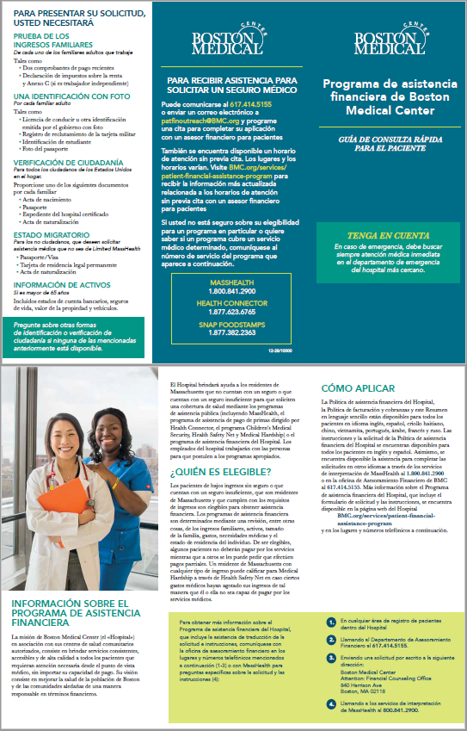









Exhibit 2_Sample Patient Statement, Notification of FAP (1 of 2)

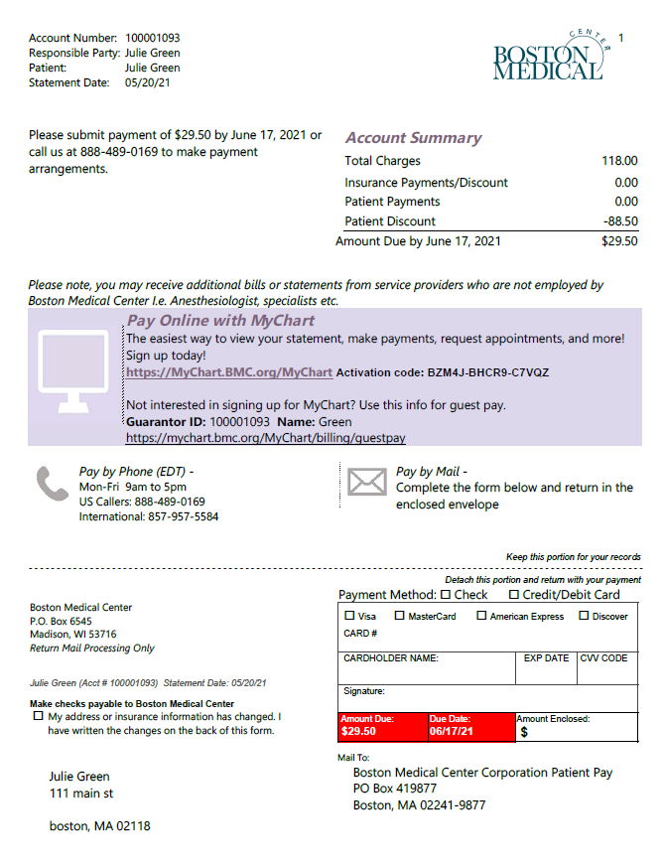

Exhibit 2_Sample Patient Statement, Notification of FAP (2 of 2)

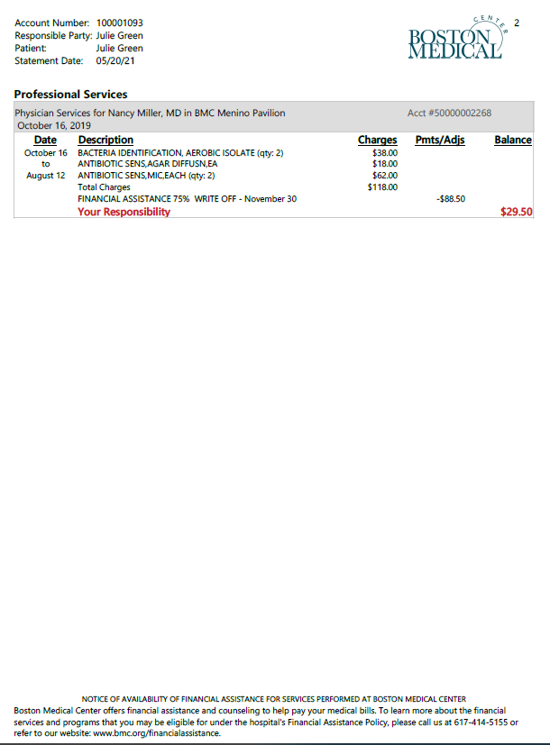

Exhibit 3_Sample Hospital Sign, Notification of FAP

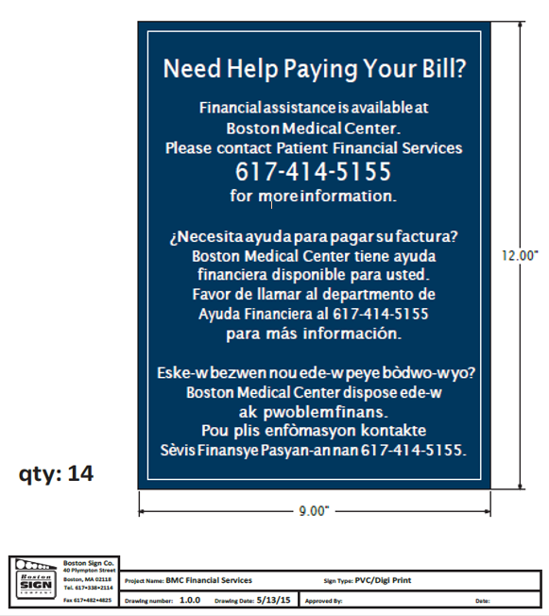

Exhibit 4_BMC Provider List

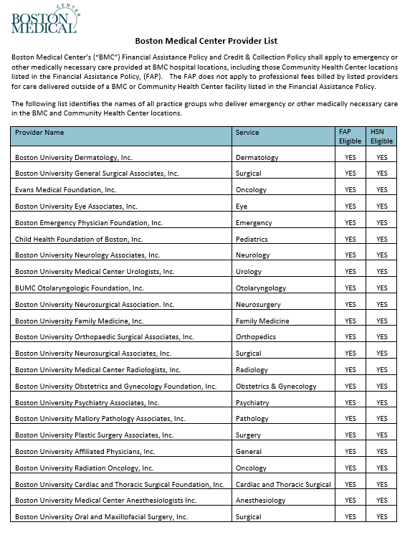

Exhibit 5 BMC Financial Assistance Approval Letter

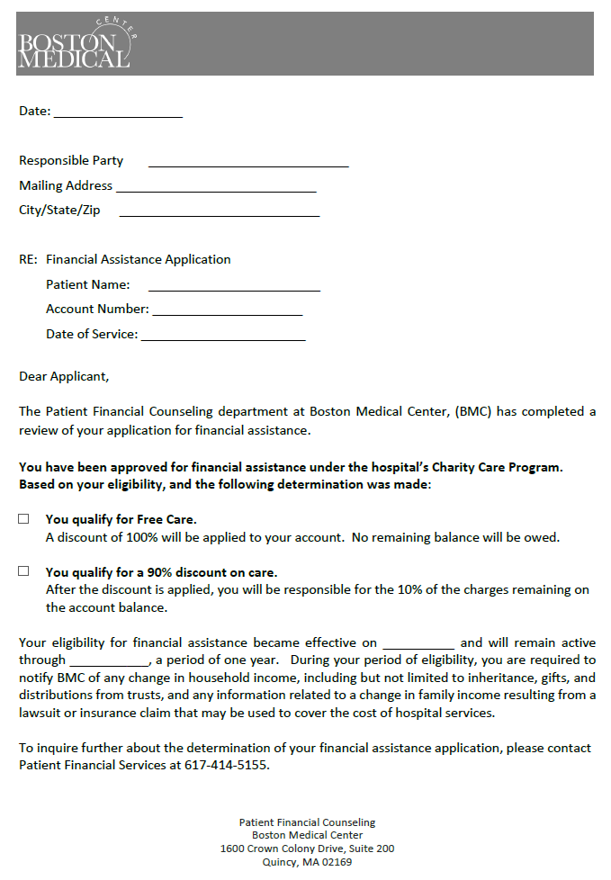

Exhibit 6 BMC Financial Assistance Program Denial Letter

