Overview of Visual Schedules
- A visual schedule uses pictures and words to better communicate the order of activities that will happen.
- Visual schedules can help clinicians and staff communicate with patients with Autism Spectrum Disorders, regardless of verbal abilities
How to Use the Visual Schedule
- Below are six sample visual schedules. Prompt the patient to look at or point to each activity before completing it.

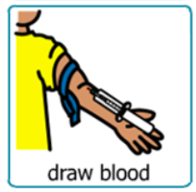
Visual Schedule #1

Visual Schedule #2

Visual Schedule #3

Visual Schedule #4
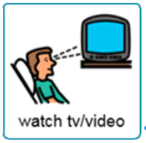

Visual Schedule #5

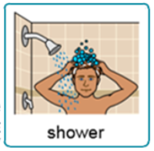
Visual Schedule #6

